KNX System arguments

KNX Association

Table of Contents
1 KNX Association: A brief outline 3
2 Activities of KNX Association – International standardization 4
3 KNX - difference compared to conventional technology 5
4 KNX System specification 6
4.1 KNX Media 6
4.2 Areas of application for the various media 6
4.3 Types of configuration 7
4.4 KNX interworking 8
4.5 KNX Secure 8
5 Success figures 9
6 The unique value propositions of KNX 9
6.1 Interworking 9
6.2 One single configuration tool 9
6.3 Wide range of KNX products from many manufacturers and large service network 10
6.4 Backward compatibility 10
6.5 Energy efficiency 10
6.6 Higher degree of convenience 11
7 KNX: Application examples 12
8 Selling the benefits 14

KNX Association: A brief outline
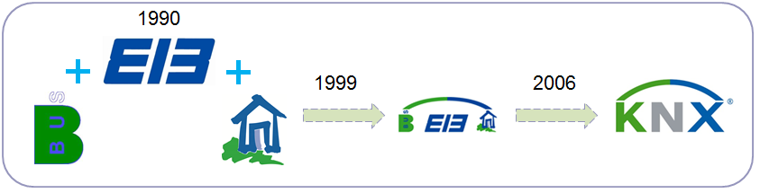
Figure 1: KNX – The history
KNX Association has been set up in 1990 with headquarters in Brussels (Belgium), at that time still called “EIB Association” or in short “EIBA”. The goal of the association was to promote smart homes and buildings in general and the EIB system in particular, which was developed jointly by some renowned manufacturers.
In 1999, this association merged with two other European associations. These are:
- BCI (France) promoting the Batibus system;
- European Home Systems Association (The Netherlands) promoting the EHS system.
As a result of this merger, the name was changed into “KNX Association”.
KNX Association has the following goals:
- definition of a new truly open standard ‘KNX™’ for smart homes and buildings;
- establishing the KNX Trademark as a token for quality and multi-vendor interworking;
- establishing KNX as a European and worldwide standard.
As EIB is backward compatible to KNX, most devices can be labelled with both the KNX as well as the EIB logo.

Activities of KNX Association – International standardization
KNX Association runs the below activities:
- The further technical development and the promotion of the KNX standard together with the KNX member companies;
- The further development of the common design and commissioning tool software called ETS™;
- Sales and support of ETS via the MyKNX portal (https://my.knx.org);
- Granting the KNX trademark for KNX compatible products (product certification);
- Promotion of KNX training measures through the certification of training centres and by making available training documentation;
- National and international standardisation activities;
- Encouraging the setup of national groups (associations of members and/or users in different countries);
- Promotion of “scientific partnerships” with technical institutes or universities in order to promote the KNX system amongst students and for research;
- Technical support for manufacturers wanting to develop KNX compatible solutions;
- Definition of testing and quality standards together with the KNX member companies;
- Promotional activities (web site, fairs, brochures…)
KNX Association consisted of 9 members when it was founded. This number has meanwhile increased to more than 400 (situation beginning 2019). The current membership list is available at any time under www.knx.org.

Figure 2: KNX in standardization

At the end of 2003, the KNX Standard was approved by CENELEC (European Committee of Electrotechnical Standardisation) as the European Standard for Home and Building Electronic Systems as part of the EN 50090 Series. The KNX Standard was also approved by CEN (EN 13321-1 for media and protocol and EN 13321-2 for KNXnet/IP). At the end of 2006, KNX was also approved as a world standard (ISO/IEC 14543-3-1 to 7). Moreover, in May 2013, the KNX technology has been approved as a Chinese standard (GB/T 20965). KNX is also approved in the USA as ANSI/ASHRAE 135.

KNX - difference compared to conventional technology
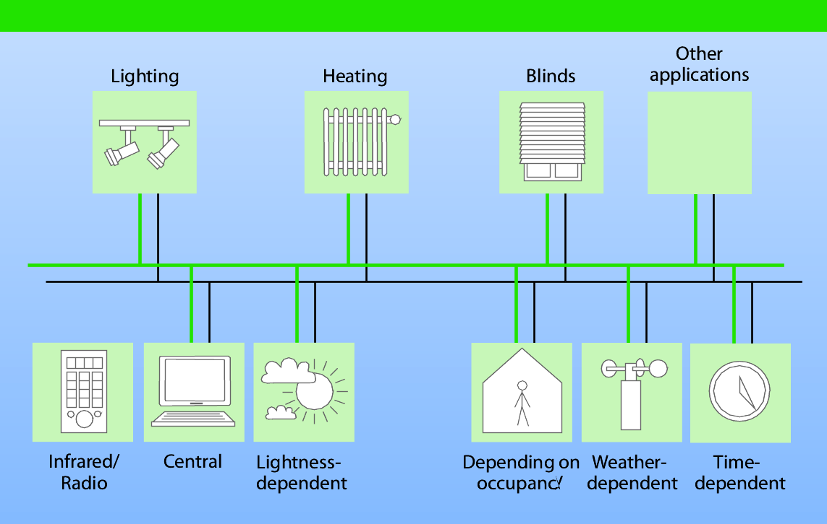
Figure 3: KNX – introduction to the technology
In the case of the most widely used medium “Twisted Pair (TP)”, a control cable is laid parallel to the 230 V cable. This results in the following advantages compared to conventional installation technology:
- the amount of cabling is considerably reduced when bus devices are arranged in a decentralized way;
- Increase in the number of possible system functions;
- Improvement of the transparency of the installation.
This control cable:
- connects loads (actuators) and switches (sensors)
- supplies power to the bus devices in most cases.

As all KNX bus devices have their own intelligence, a central control unit (e.g. PC) is not necessary. KNX can therefore be used in both small installations (flats) as well as in large projects (hotels, administration buildings...).

KNX System specification

KNX Media
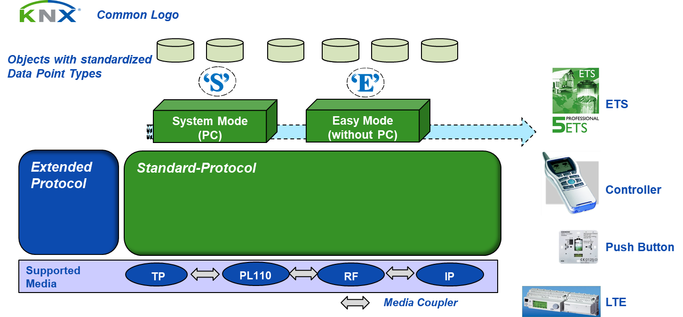
Figure 4: KNX System overview
As explained in the previous paragraph, the exchange of KNX data between devices is typically done via a separate control cable. KNX data can also be sent via the existing 230 V cable (“Powerline transmission medium”), wireless (“KNX Radio Frequency transmission medium”) and via Ethernet/WIFI (“KNX IP”). Via appropriate gateways, transmission of KNX telegrams is also possible on other media, e.g. optical fibre.
When connecting different media, appropriate media couplers have to be used. The used medium of a device is visible on the product’s label.

Areas of application for the various media
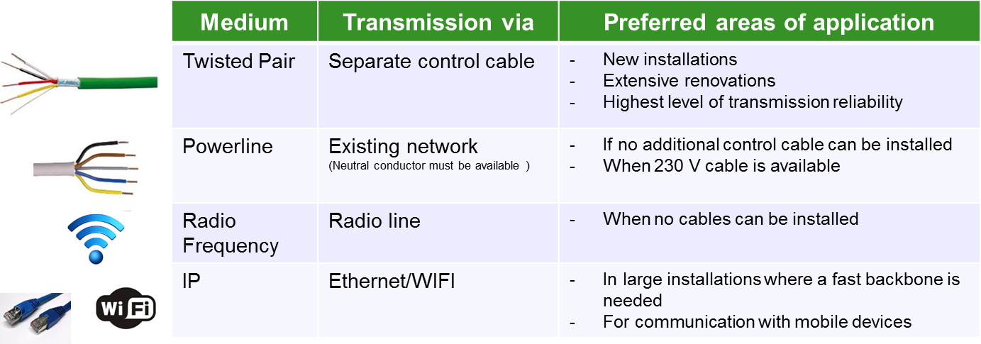

Figure 5: Areas of Application for the various media

Types of configuration
Depending on what is marked on the label of the device, devices can be configured (i.e. linked and setting of parameters) via:
- Easy installation Mode (E-Mode): configuration is done without the help of a PC but with a central controller, push buttons…
This type of configuration is intended for the skilled contractor with basic bus knowledge. Easy compatible products normally have limited functionality and are intended for medium size installations.
- System installation Mode (S-Mode): design of the installation and configuration is done via a PC with the installed manufacturer-independent ETS software, whereby the manufacturers’ product data are imported in ETS.
This type of configuration is intended for KNX certified building designers and contractors and for large size installations.
Some devices allow configuration via easy installation as well as S-mode Mode. For instance, products with the LTE label are normally configured via the LTE (Logical Tag Extended) mechanisms: all devices however include a defined S-mode interface, which allows linking them with S-mode compatible devices.

KNX interworking
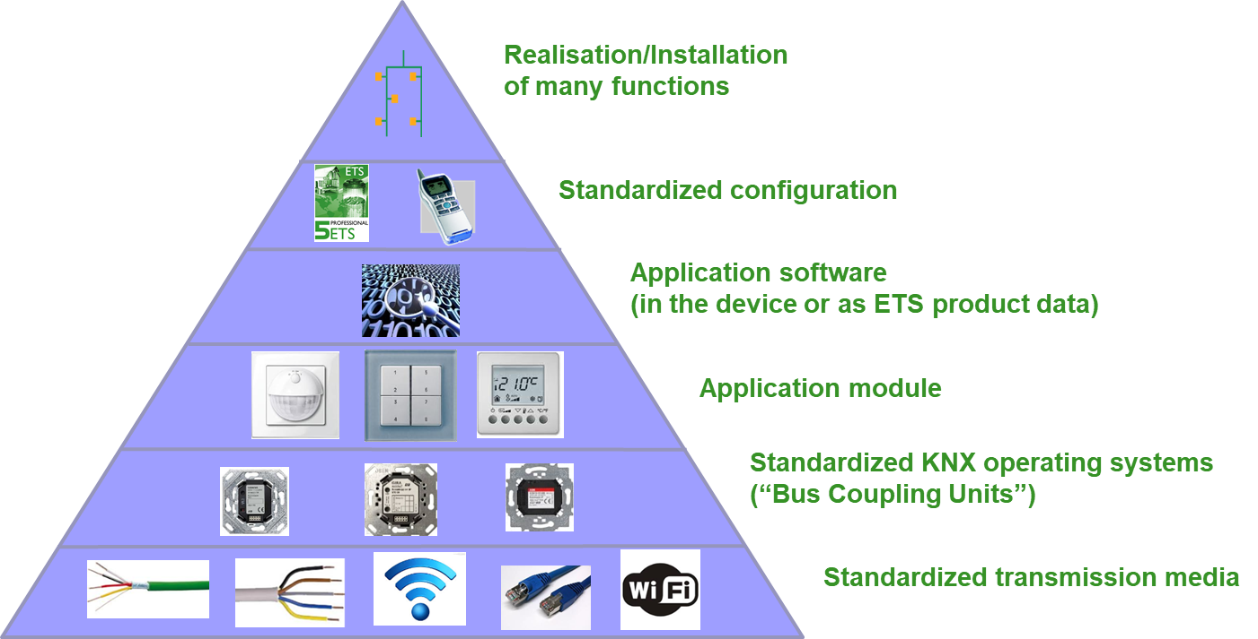Figure 6: KNX interworking
Devices from different KNX manufacturers and functional areas that are labelled with the KNX trademark and using the same configuration mechanism can be linked to form a functioning installation thanks to the KNX standardization of
- Telegrams: devices usually use standard telegrams for transmission, but in exceptional cases they also use telegrams with extended length for the transmission of bulky data ;
- Useful data in telegrams: for various functions (amongst others switching, dimming, shutter control, HVAC …), predetermined formats need to be used in KNX certified devices.

KNX Secure
When taking the proper measures given in the KNX Security Checklist (see https://www.knx.org/wAssets/docs/downloads/Marketing/Flyers/KNX-Secure-Checklist/KNX-Secure-Checklist_en.pdf), KNX installations can already be to a great extend protected against unwanted manipulations.
However, for some media (RF, IP) and for some building types, it may be desired to take additional security measures.
For this, KNX Secure has been designed as KNX a system extension, allowing securing access via IP (KNX IP Secure) as well as communication between individual devices (KNX Data Secure).
Devices that can support KNX Secure can be recognized via their product label.
Detailed explanations on KNX Secure are given in the KNX Advanced course.

Success figures
- Millions of installed products
- thousands of KNX registered and certified products
- more than 400 KNX members (manufacturers)
- more than 400 recognized training centres
- 15 international test labs
- hundreds of thousands of implemented projects

The unique value propositions of KNX

Interworking
One of the biggest advantages of KNX is undoubtedly the “Interworking” between KNX products of different KNX manufacturers. Because all KNX products “speak” and “understand” the same language, they can communicate with each other, e.g.:
- The presence detector from manufacturer A can interact with the alarm system of manufacturer B;
- The room thermostat of manufacturer A changes the position of the valves of manufacturer B;
- The “All off” button of manufacturer A switches the lights off, controlled by switch actuators of manufacturer B, C, D, …;
If after a while, product A is defective (or the manufacturer of this specific product has discontinued the product line, or the homeowner does not fancy the product anymore etc.), he/she can still have it replaced with product B from another KNX manufacturer, with the same or similar functionality. With the help of the ETS, the new product can be seamlessly integrated in the existing installation.

One single configuration tool
Using different home and building automation systems (e.g. one for lights, one for HVAC, one for sun shading, etc.) mostly entail that the system integrator needs to master various software packages or configuration methods to install the devices.
Software programs provided by one manufacturer or even for different devices may have a completely different look & feel, even when manufacturers update their products. This ultimately leads to an increased training effort from the side of the system integrator.
In KNX however, one only needs to get proper training in one software tool, i.e. ETS, to be able to configure KNX products that are used in different application domains and from different manufacturers.
In ETS, one is able to import from a central repository product data entries from any KNX manufacturer. Because ETS is backwards compatible, the system integrator can even import in the most recent version of ETS product data entries that were initially released for much older generations of ETS. This means that a project that was created years ago can still be imported in the newest version of ETS and can still be modified or even extended.
Another not to be underestimated advantage of one tool is the fact that this tool – especially for larger size installations – documents in full detail which functions of the installed products are linked to each other. In other words, both integrator as well as home/building owner have a complete documentation of their installation.
The KNX Tool is available in two different flavours and for different target groups, i.e.
- for the Professional integrator (“ETS Pro”) and for use on desktop/laptop (Windows) computers;
- for the less KNX acquainted integrator (“ETS Inside”) and for use on mobile devices (smart phones and tablets, even with other operating systems than Windows).

Wide range of KNX products from many manufacturers and large service network
Home or Building owners have a wide range of available products from different manufactures allowing finding the product that suits their needs the most, depending on functionality (e.g. push buttons with or without scene control) and/or design.
If the home or the building owner wishes to modify or extend the installation, he has access to a large service network of qualified KNX integrators/building designers. Even if his previous integrator is no longer active in KNX, the KNX website for sure lists an alternative KNX integrator in his vicinity.

Backward compatibility
In its nearly 30 years of existence, the KNX system has not experienced one single break in compatibility, meaning the earliest installations can still be extended with the most recent product releases of manufacturers.

Energy efficiency
As a result of global climate change and increasingly scarce resources, in the recent years building regulations have put greater emphasis on sustainability, whereby even the use of building automation becomes imperative.
Building automation allows you to:
- better integrate the different applications in a home or building, i.e. lighting, sun shading and heating/cooling are fully synchronized, no application siloes that work alongside each other or worse against each other;
- better adapt the different applications to external climate conditions (e.g. with the help of a weather station, measuring not only external temperature, but also light intensity, …);
- Sensors from one application domain can also interact with receivers of other application domains (e.g. presence detector influences lighting as well as heating/cooling);
- Rooms or parts of the building can be individually controlled instead of centrally;
- Measure the consumption even at the level of the function (e.g. with energy actuators) rather than globally for the installation;
Above measures allow to considerably reduce energy consumption and investment in additional building automation equipment therefore has a rapid Return of Investment.

Higher degree of convenience
In situations where the home owner desires a large number of different functions, KNX will be more cost-efficient and easier to install than any other equivalent conventional system.
Through simple adaptions to the KNX installation the system integrator will be able to fulfil the demands of the house owner, e.g. when:
- A new tenant of an office building has different electrical requirements than the previous tenant;
- A private home needs to be transformed into a (private) nursing home, when inhabitants age or become less mobile;
- The home owner desired more security through the installation of additional (glass-break/window) sensors, presence simulation devices, etc.

KNX: Application examples
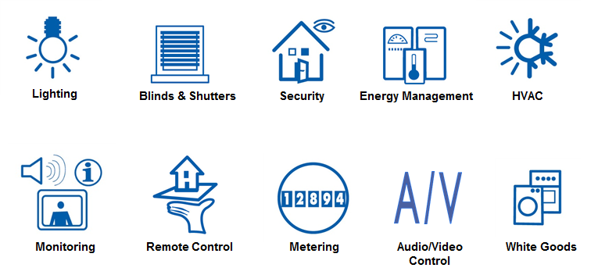
Figure 7: Possible application fields
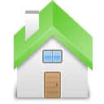 | Example 1: Implementation of central functions – when you are leaving the building, all lights, the water supply and specific sockets (electric oven…) can be switched off, the KNX alarm system can be activated and the blinds can be controlled dependent on the time of day, all with a single command.
 | Example 2: In conference rooms, theatres as well as living rooms, it is possible to activate different light scenes depending on the activity. These light scenes can also be modified by the user at any time. For example in administration buildings, it is possible to achieve an energy saving of up to 75% for lighting by implementing constant light control with only one brightness sensor on each building façade.
 | Example 3: All the states of the equipment in a flat can be indicated in clear text and controlled via display units (fixed but also mobile devices such as smartphones or tablet computers). In the same way, this can be implemented in larger installations using PCs and visualisation software.
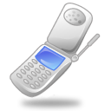 | Example 4: By interfacing a KNX installation with the telephone network, the user can influence or query the building management functions (e.g. the heating) using a mobile phone. Alarm signals can be automatically routed to any required telephone number. KNX installations can also be remotely serviced and configured by the installer using any available media (e.g. the Internet). The time required for maintaining the building management system is thus considerably reduced.
 | Example 5: A large conference room should be divided into several independent areas, if the need arises. By inserting partition walls, the KNX installation automatically detects the required assignment of switches and lights per room section. It is therefore not necessary to change the existing cabling.
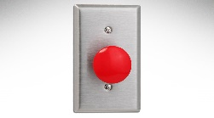 | Example 6: Any number of panic switches (e.g. activation of all the lights) can be installed.  At night, the lights between the children’s bedroom and the bathroom can be activated by pressing a button and deactivated after a set period.
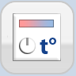 | Example 7: KNX enables individual room control of the heating and cooling system with the creation of heating and cooling profiles per room. The heat or cold input for a room is automatically adjusted when a window is opened. In this way, an energy saving of more than 30% per year can be achieved.  The heat generation can also be controlled dependent on the heat requirement of the individual rooms (heat is only produced when it is actually required).
 | Example 8: KNX enables presence simulation during the absence of the building owner.
 | Example 9: The energy consumption of individual electric circuits can be monitored by energy sensors /energy actuators and can be switched off for load management when exceeding predefined threshold values. Combined with a gateway to Smart Metering devices or renewable energy sources, it is therefore possible to ensure the optimal use of self-generated energy (e.g. in combination with a future electric vehicle).
 | Example 10: Smart virtual assistants that support voice control such as Alexa from Amazon or Google Home can be connected to the KNX installation. By simple voice instructions, the homeowner will be able to lower the shutters, switch on/off or dim the lights, increase the temperature etc.

Selling the benefits
During a consultation with a future customer, the electrical contractor or designer should discuss KNX only in terms of its benefits to the customer and focus on the customer’s needs. Technology and costs should at first not be in the foreground. This discussion should result in a system quotation rather than a component quotation. The process should continue as follows:
- Discuss the system quotation with the customer and again stress the benefits for the customer;
- If the price for the system is not acceptable, functions should be redesigned (e.g. switching instead of dimming);
- In extreme cases, the price of the installation can be reduced using the following components:
- push button interfaces (that are connected to conventional push buttons)
- push button BCUs
- multiple fold switch/combo actuators

For current figures, please consult the KNX web site (www.knx.org)

