KNX TP Topology

KNX Association

Table of Contents
Introduction 4
1 Topology - Overall view 5
2 Topology - Line 6
3 Topology – Area 7
4 Topology - Several areas (Network) 8
5 Individual address 9
6 Coupler - Gate function 10
7 Coupler - Block diagram 11
8 Coupler - Fields of application 12
9 Connecting several lines 13
10 Practical example for explanation of functionality 14
11 Internal line telegram 15
12 Line-crossing telegram 16
13 Area-crossing telegram 17
14 Coupling unit: Routing counter 18
15 KNX - Internal and external interfaces 19
16 Topology –Structure in building 20
17 Backbone- /Line coupler classical structure 21
18 Taking into account higher telegram rates: IP Network 22
19 Line couplers replaced by KNXnet/IP routers 24
20 Limits to the use of KNXnet/IP routers 25
21 Informative annex - old line coupler type 26

In this chapter, the following abbreviations are used:

BC = Backbone coupler
LC = Line coupler
DVC = Bus device
LR = Line repeater
PS/Ch = Power supply with choke
S = Brightness sensor
RC = Routing counter
Introduction
A distinction shall be made between KNX installations that were planned and commissioned before & after 2018.
Before 2018:
Only 64 TP devices can be mounted in one line segment. A segment can however be extended by 3 other line segments thereby using appropriate line repeaters.
After 2018
If an installation is realized after 2018, then it is also allowed to mount 256 TP devices in one line without the use of line repeaters.
Important notes:
- Devices that are shipped from January 2019 are assumed to allow mounting of 256 devices in one line without line repeaters. In case of doubt, consult the manufacturer’s product data sheet. The product label does not inform on this.
- The topology of installations that were erected before 2018 shall be left untouched and no additional devices beyond 64 shall be installed in one line segment.
- A line repeater is the same hardware as a line- /backbone coupler. It is the loaded application program and its corresponding individual address that determine whether the hardware becomes a “line repeater”, a “line coupler” or a “backbone coupler
The number of devices that can be installed in one line also depends on the power consumption of every installed device. The power consumption of all mounted devices may not exceed the output voltage of the installed power supply unit.

Topology - Overall view
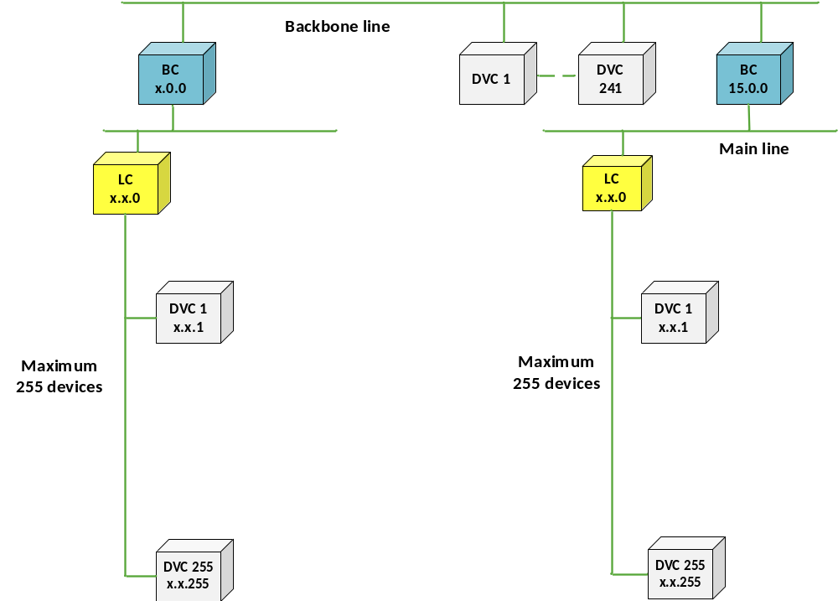
Figure 1: Maximum topological size of a KNX TP installation
In the above figure, the maximum topological size of a KNX-TP installation that is realized after 2018 is shown. No line repeaters are required and hence no line extensions are possible.
In the below illustrations, the details of a KNX TP installation are described one by one.
In the below explanation and in several other chapters of this course documentation, the following terminology is used:
- Primary line: this term refers to the upper segment of a line or backbone coupler, the “North” side, e.g. in case of
- a line coupler, this is the main line;
- an IP router, this is the IP side.
- Secondary line: this term refers to the lower segment of a line or backbone coupler, the “South” side, sometimes also referred to as the sub line, e.g. in case of
- a line coupler, this is the line itself.
- an IP router, this is the TP side.

Topology - Line
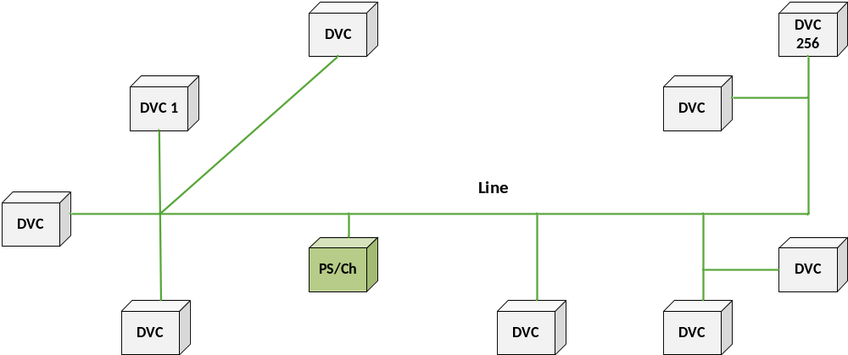
Figure 2: Topology - line and line segment
Maximum 256 devices can be mounted in one line.
By means of telegrams, each bus device (DVC) can exchange information with any other device. Each line requires its own appropriate power supply.
The actual number of devices per line depends on the power supply selected and the power required by the individual devices. The bus cable can be branched at any place.
The following structural types are allowed: star, line and tree structures (also in combination). A ring structure is however not allowed. A tree structure allows saving wiring material.

Topology – Area
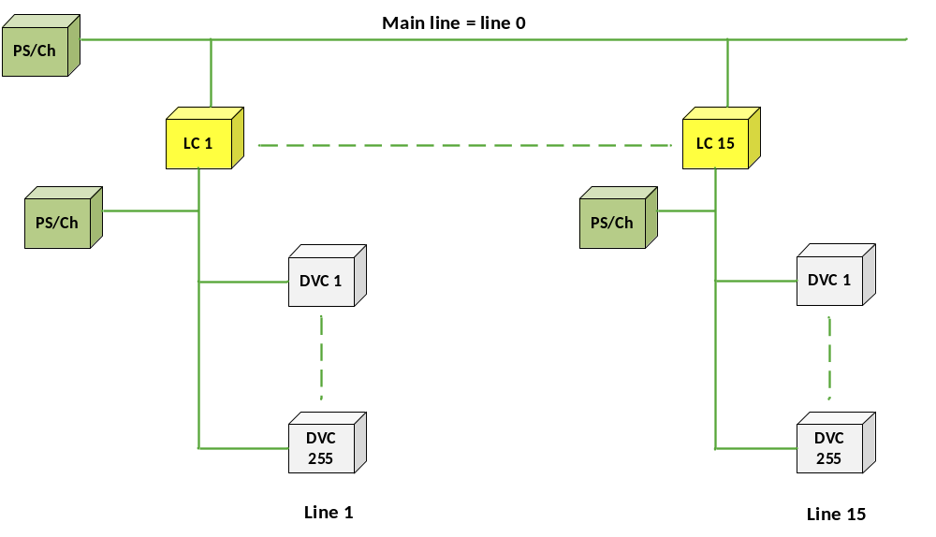
Figure 3: Topology – area

If more devices have to be mounted than one can fit into one line, then up to 15 lines can be connected to a main line via line couplers (LC). This line structure is called an area.
As the used line couplers topologically belong to the secondary line, the maximum number of bus devices in the main line decreases – due to the energy consumption – by the number of mounted line couplers (see Coupler – Block diagram).
Line repeaters may not be used in main lines, also not in installations before 2018.
This means that it is possible to topologically address maximum 256 bus devices on the main line, including the mounted line couplers.
Each line, but also the main line requires its own power supply.
In this topology, more than 4,000 devices can be installed.

Topology - Several areas (Network)
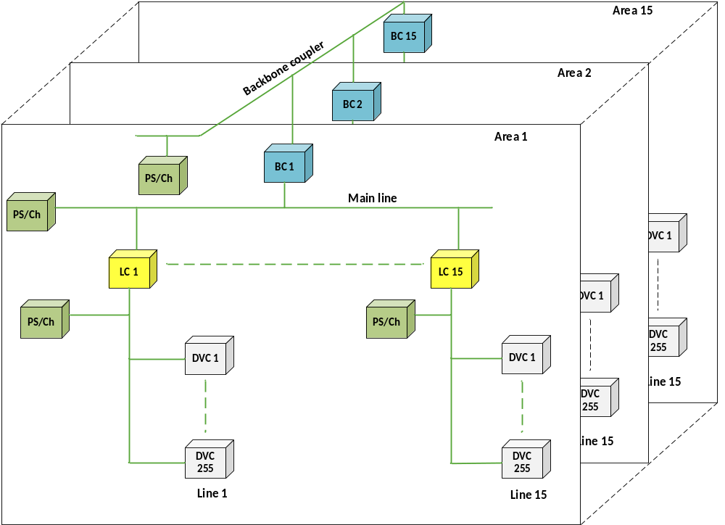
Figure 4: Topology - several areas
If even more devices have to be mounted in a KNX installation, then the TP installation can be extended by mounting backbone couplers (BC) to the backbone line.
As the used backbone couplers belong topologically to the secondary line, the maximum number of bus devices on the backbone line decreases – due to the energy consumption – by the number of mounted backbone couplers (see Coupler – Block diagram).
Line repeaters may not be used on backbone lines, also not in installations before 2018. The backbone line requires its own power supply.
By dividing the KNX TP installation into lines and areas, the functional reliability is increased considerably.
This means that it is possible to topologically address maximum 256 bus devices including the mounted backbone couplers on the backbone line
In this topology, more than 61,000 devices can be installed in a complete TP-Network.

Individual address
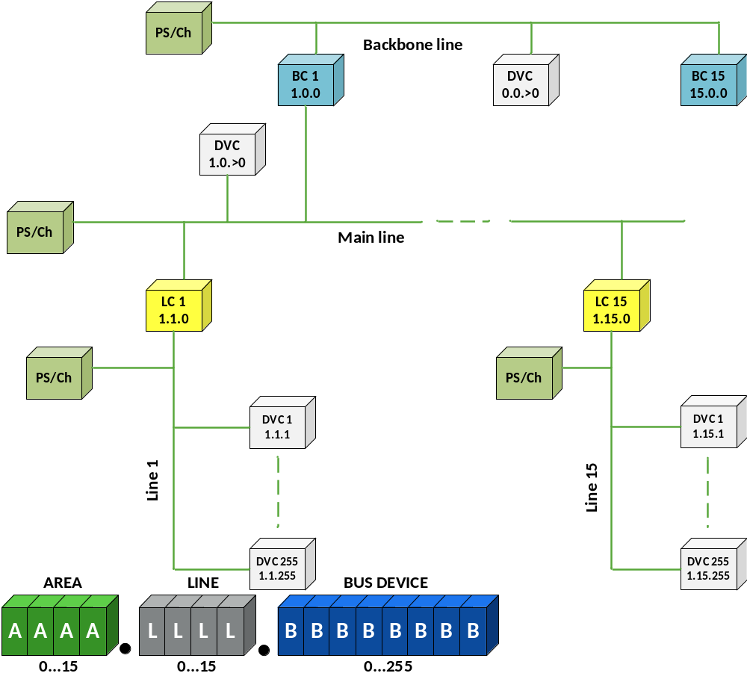
Figure 5: Individual address (situation showing an installation planned and commissioned after 2018)
The individual address serves to clearly identify the bus device and describes its location within the topology.
A = 1…15 addresses the areas 1…15
A = 0 addresses the bus devices on the backbone line

L = 1…15 addresses the lines 1…15 in the areas defined by A
L = 0 addresses the main line of the respective area

B = 1…255 addresses the bus devices on the line defined by L
B = 0 addresses the coupler in the respective line
The individual address of an unloaded bus device is 15.15.255.
New bus devices are typically delivered ex-factory with the individual address 15.15.255.

Coupler - Gate function
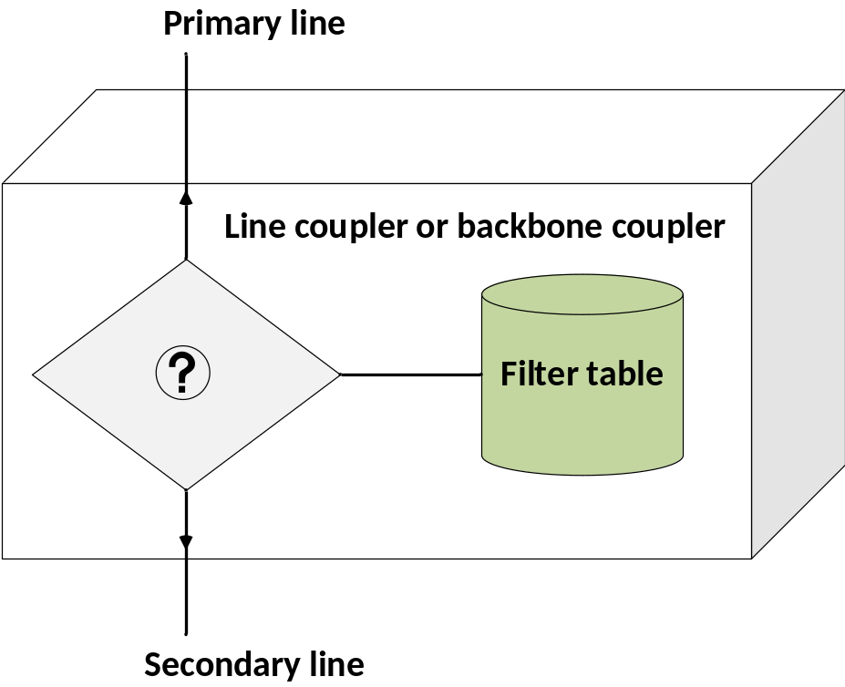
Figure 6: Coupler: gate function
If a coupler (line -/ or backbone coupler) is used in the installation and the correct individual addresses are assigned to the corresponding couplers, a filter table will be automatically created in ETS for the respective couplers during the planning and design stage.
This filter table contains the active line-crossing group addresses (i.e. all group addresses that address bus devices that are located on the “other” side of the coupler).
The coupler routes all received group addresses if these are listed in its filter table.
In this way, each line works independently. Only line-crossing telegrams are routed.
The yellow LEDs on the coupler flicker when a telegram is received on the respective line.
The line repeater used in installations before 2018 passes on all telegrams; it has no filter table.

Coupler - Block diagram

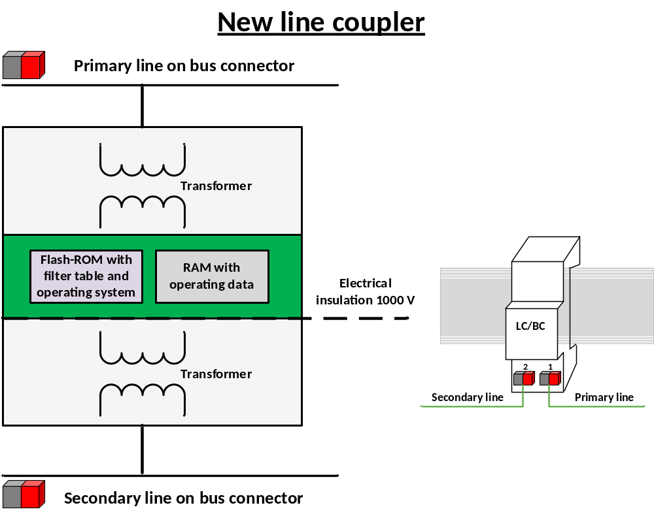
Figure 7: Block Diagram: Line coupler type (as from July 2003 onwards)

The coupler is designed for DIN rail mounting. In operation, for line couplers the primary line as well as the secondary line is connected via standardised bus connectors.
The line coupler can be programmed both from the primary line as well as from the secondary line.
The couplers are supplied from the primary line and only have one controller. This has the advantage that the coupler can report secondary line power-down.
The couplers are equipped with Flash ROM memory. Contrary to the old coupler types (see § 21 for more information), they do not need backup battery power for supplying the memory containing the filter table.
The couplers galvanically isolate the lines from each other.

Coupler - Fields of application
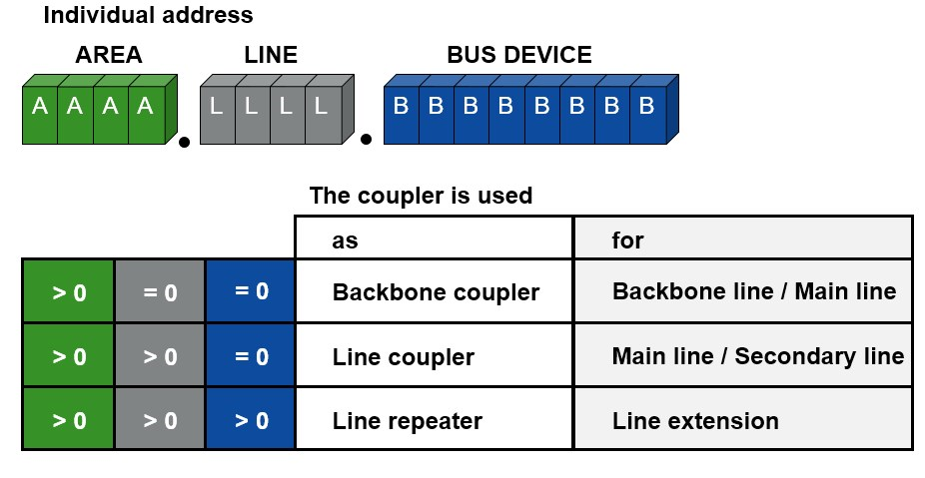
Figure 8: Coupler: fields of application

Backbone couplers, line couplers and line repeaters are identical devices. Their tasks depend on the location and the corresponding assigned individual address.

The coupler can be used as:

Backbone coupler BC |  | Connection between: backbone line – main line
Line coupler LC |  | Connection between: main line – secondary line
Line repeater LR |  | For extending a line by a line segment with up to 64 additional bus devices and an additional cable length of 1,000 (used in installations before 2019)

Backbone couplers and line couplers only forward line-crossing telegrams.
The line repeater does not have a filter table and therefore passes on all telegrams.
It is the assigned individual address that determines a coupler either as a backbone coupler, a line coupler or a line repeater. The address 1.1.0, for example, defines the device as the line coupler of line 1 in area 1.
The line coupler monitors the data communication between the main line and the secondary line and vice versa. Only the telegrams of which the group addresses are stored in its filter table are routed.

Connecting several lines
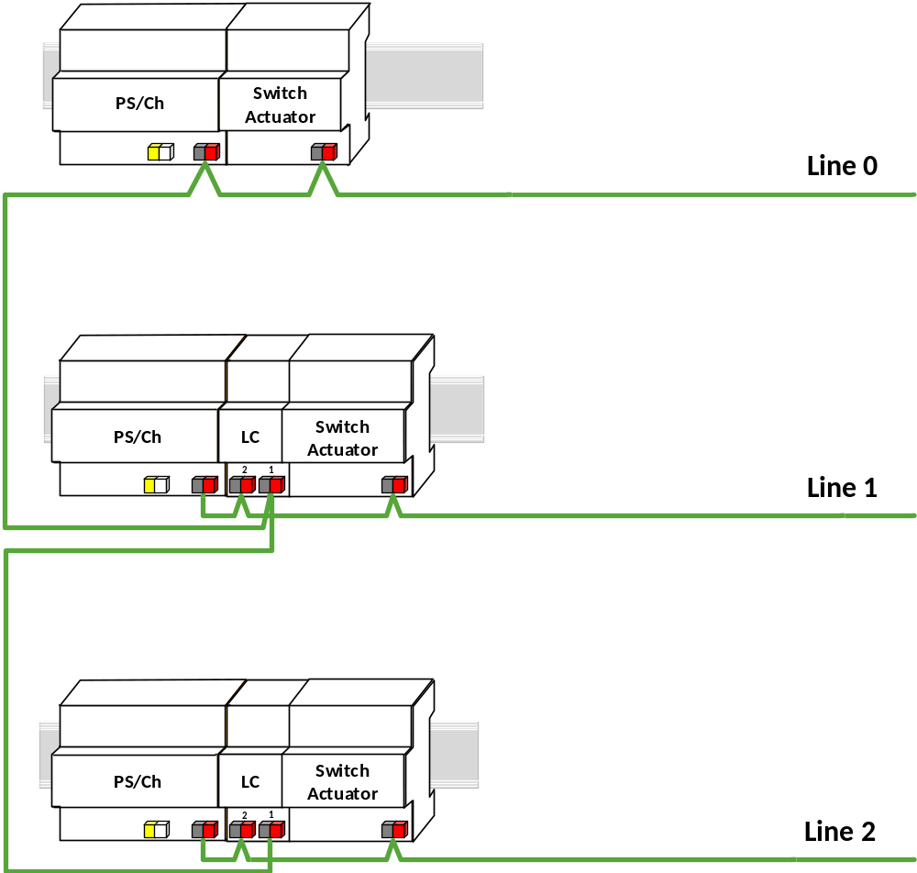
Figure 9: connecting several lines

In an installation consisting of several lines, each line or each line segment must have its own power supply unit and choke.
The above figure shows a power supply unit with an integrated choke as well as the line coupler.
Both lines, the secondary line (e.g. line 1) as well as the primary line (line 0) are connected to a line coupler via standard bus connectors.

Practical example for explanation of functionality
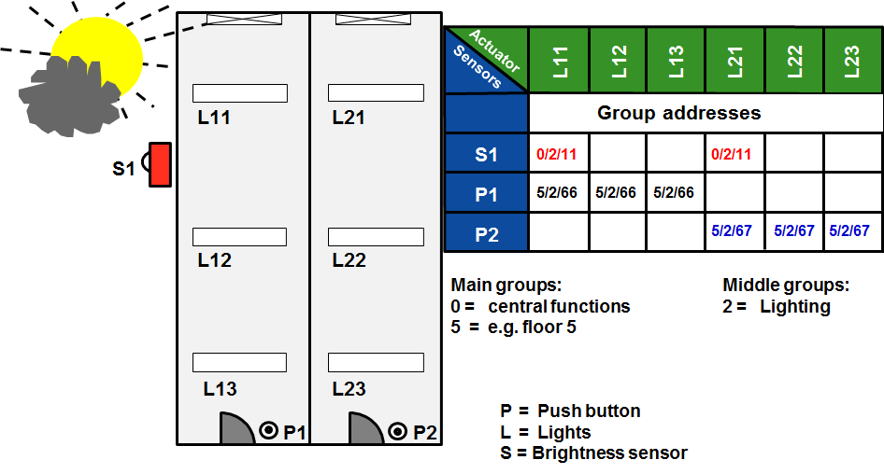
Figure 10: Practical example

The push button P1 shall switch the lights L11, L12 and L13. During configuration, group address 5/2/66 is attributed to the push button. The same group address is also attributed to the actuators controlling the before-said lamps.
The push button P2 shall switch the lights L21, L22 and L23. During configuration the group address 5/2/67 is assigned to it. Again, the same group address is attributed to the actuators controlling these lamps.
The brightness sensor S1 shall also switch the lights next to the window (L11 and L21). Group address 0/2/11 is therefore attributed to the sensor as well as to the actuators controlling the window lights (L11 and L21).
The window lights can therefore be switched via the push button as well as the brightness sensor.

Internal line telegram
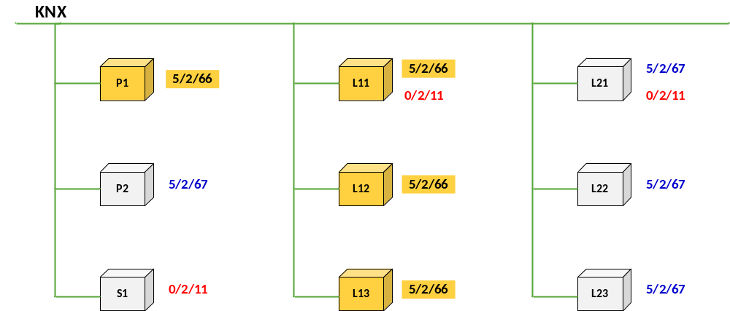
Figure 11: Internal line telegram

Pressing push button P1, sends a telegram with the group address 5/2/66.
Although all bus devices listen in when the telegram is transmitted, only the actuators of lamps L11, L12 and L13 with the same group address 5/2/66 execute the command.
If the brightness sensor (S1) sends the group address 0/2/11, all the bus devices on this line listen in but only the actuators of the window lights L11 and L21 execute the command.

Line-crossing telegram
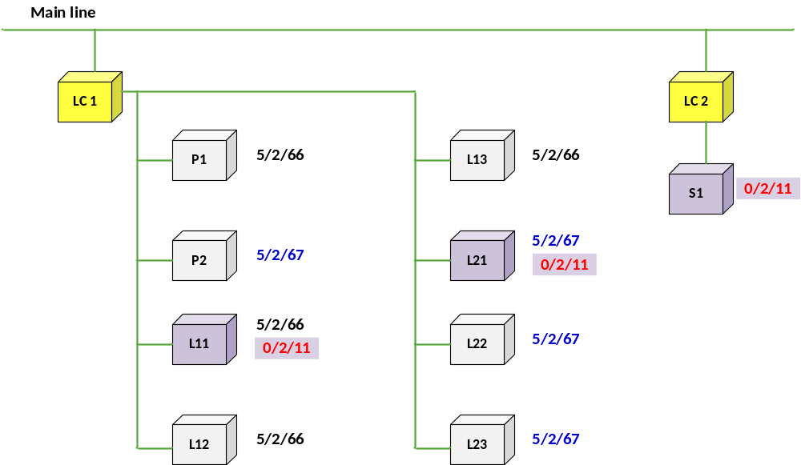
Figure 12: Line-crossing telegram

If the brightness sensor (S1) is not connected in the same line as the lamp it has to control, it is necessary to transmit its telegrams via the main line.
By its parameterization, the line coupler LC 2 is aware of the fact that there are bus devices outside its own “line 2” responding to telegrams transmitted by the brightness sensor. LC 2 therefore routes the group telegram 0/2/11 onto the main line.
Line coupler LC 1 is aware of bus devices on its “line 1” that respond to the group telegram 0/2/11 and therefore transmits the telegram into its line.
All bus devices on this line listen to the telegram from the brightness sensor but only the actuators controlling the lights L11 and L21 execute the command.

Area-crossing telegram
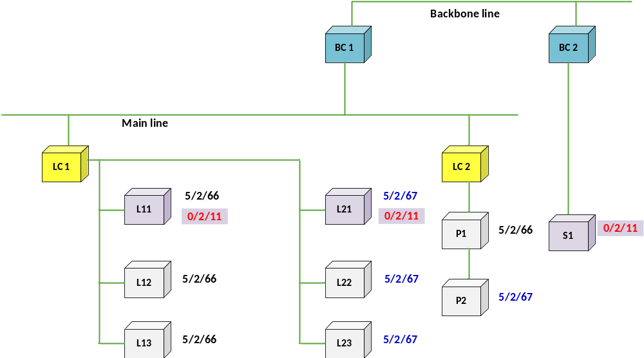
Figure 13: Area-crossing telegram

If brightness sensor S1 is mounted in another area, it can still address all bus devices via the backbone line.
If the group address 0/2/11 is assigned to the brightness sensor, the telegram is routed to line 1 via the backbone couplers BC 1 and BC 2 and line coupler LC 1.
The actuators controlling lights L11 and L21 in area 1, line 1 then execute the command.

Coupling unit: Routing counter
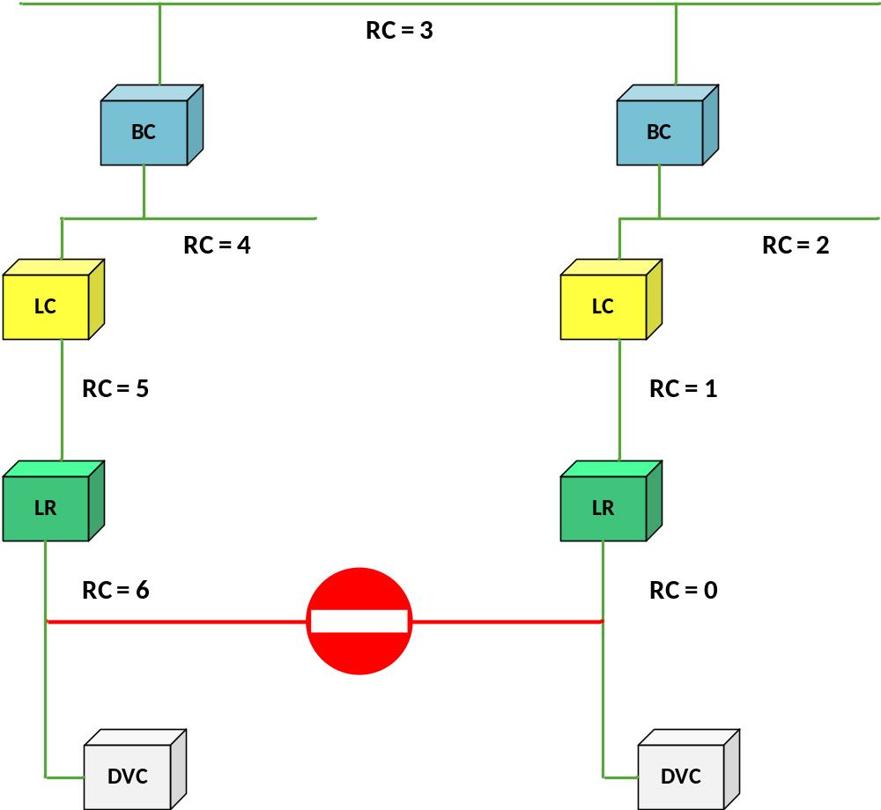
Figure 14: Routing counter

The telegram transmitted by the sending device contains a routing counter, of which the initial count value is 6.
Each line - /backbone coupler or line repeater decrements the routing counter and passes on the telegram as long as the value has not reached 0. It goes without saying that the filter table entries are taken into account before the telegram is passed on.
If a service device (e.g. ETS), however, transmits a telegram containing a routing counter with the value of 7, the coupler will not alter this value. In this case, the filter table is ignored and all couplers in the installation will route the telegram. It finally reaches the bus devices it is intended for, no matter which line they are connected to.
In case of (unintentional) loops in the installation, the routing counter limits the number of circling telegrams.

KNX - Internal and external interfaces
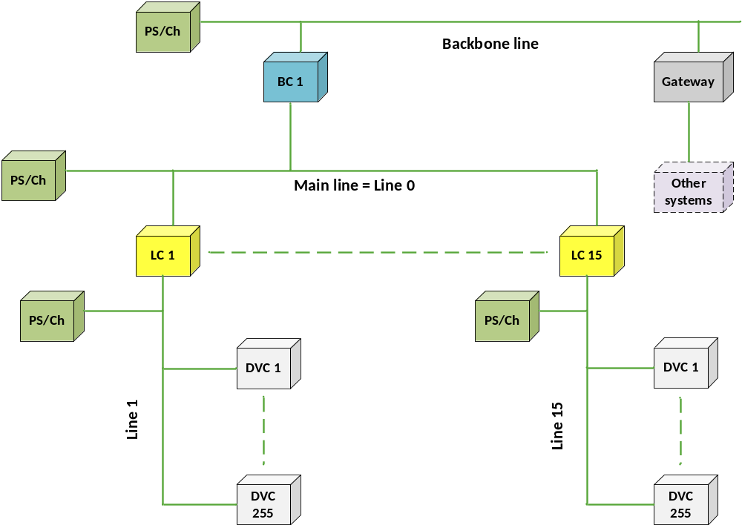
Figure 15: KNX - internal and external interfaces

KNX is open to be linked to any other system. The backbone line (or any other line) can be connected via a gateway unit to e.g. PLC, ISDN, building management technology, Internet etc.
The gateway unit converts the protocol bi-directionally.
Media couplers connect different types of KNX media (e.g. Twisted Pair and RF).
Parts of KNX installations can also be linked via optical fibre. The benefits of this are electrical separation and greater cable lengths.

Topology –Structure in building
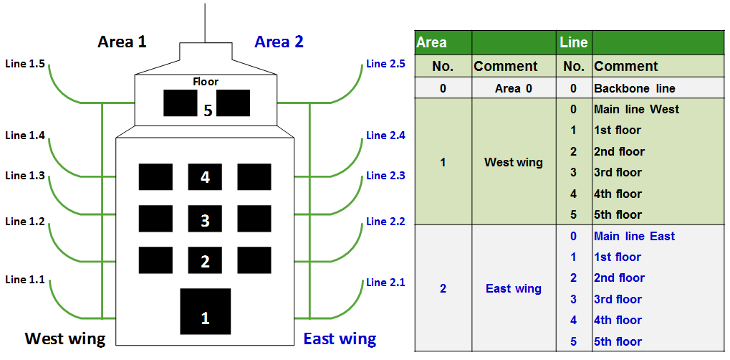
Figure 16: Division of lines in a medium sized project (example)

After the above theoretical introduction, some practical information (the above picture is by the way explained in detail in chapter “ETS Project Design – Advanced”).
Ideally, a building planned and commissioned before 2018 does not contain more than 64 installed bus devices per floor (256 KNX TP devices in case the installation is done after 2018). One can – as shown in the above pictures, make a division according to the different wings of the building. It is clear that in this case the better overview will be realised when line numbers correspond to floor numbers and area numbers correspond to building - or wing numbers.

Backbone- /Line coupler classical structure
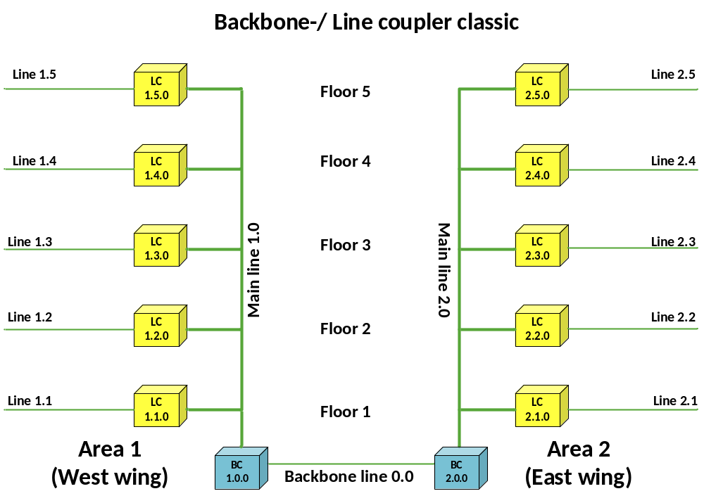
Figure 17: Backbone- /Line coupler classical structure

Of course, it will not be possible to realize this under all circumstances. As line repeaters can be installed (as already indicated before), such a floor may be equipped with up to 253 devices, without having to violate the above structure (taking into account that line repeaters have to be counted double as discussed before, the normal maximum number of devices of 256 is reduced by 3). With that many devices it is possible to realize nearly any application, thanks to the current evolution in the development of KNX devices and the availability of input - / output devices with in the mean while more than 16 channels.

Taking into account higher telegram rates: IP Network
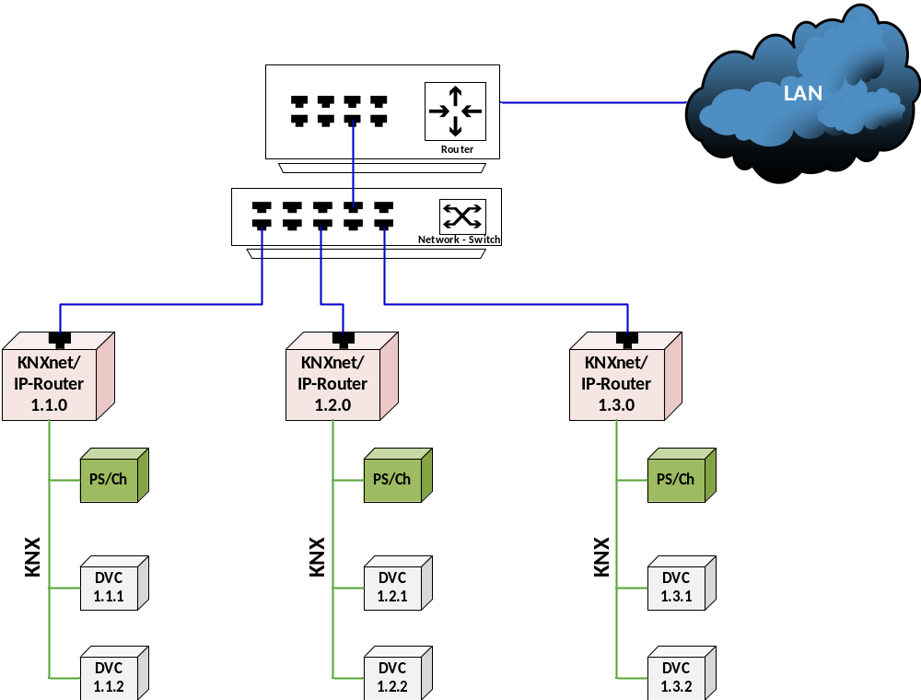
Figure 18: IP Network: higher telegram rates
As explained in the previous paragraph, gateways to other systems can be installed on all levels. Increasingly, this is requested in bigger projects because of higher customer demands.
An important reason to replace line couplers by KNXnet/IP routers is the increased telegram load, which can occur when the user makes use of visualisation software and devices with a higher number of channels, all of which automatically return multiple status acknowledgements. A pure TP topology would be overloaded as transmission speed on main – and backbone lines is limited to 9.600 bits per second. In such a case, one can easily use an IP network as a substitute for main – or backbone lines, by using the appropriate coupler.
As you can see from the above picture, the main line has been replaced by an IP network. This has the advantage that all vertical operations e.g. the (bi-directional) communication between a building control system and KNX is only determined by the bit rate of the secondary line (Ethernet is at least 1000 times faster; with the so-called “Gigabit” – switches it is possible to transmit data on the Ethernet 100 000 times faster). The parallel connection of several lines is no longer an issue. The standardized type of communication applied here is called “Tunnelling”. It is in other words the well-known gateway function, which is also used by ETS for remote programming across IP. A building control system can be connected simultaneously to several gateways, multiplying the total data rate.

A different story is the direct communication between the individual KNX lines. The KNXnet/IP router makes use of another procedure that is called “routing”, or the actual line coupler function. Principally it works in the same way as routing across a TP main line:
A KNXnet/IP router wanting to send a line-crossing telegram, will send this telegram with a so-called “Multicast” IP address into Ethernet. All other KNXnet/IP routers are connected to this multicast address, and are able to receive and evaluate this telegram. The normal line coupler function is now again applied, i.e.
- the comparison with the filter table (group telegrams) also required here or
- the line address (individual addressed telegrams)
resulting in the blocking or routing of telegrams, depending on the case.
Please note the following with regard to multicast addresses:
- There is a dedicated worldwide registered KNX multicast address, which is pre-programmed in the software of the KNXnet/IP router. This multicast address can be changed within the limits of the available address range for IP communication.
- The network switch and area router in the LAN network must be fit to handle multicast telegrams. In case of doubt, you should discuss this matter in advance with your network administrator.
- The multicast addresses cannot be used across Internet, except across a VPN connection.

Line couplers replaced by KNXnet/IP routers
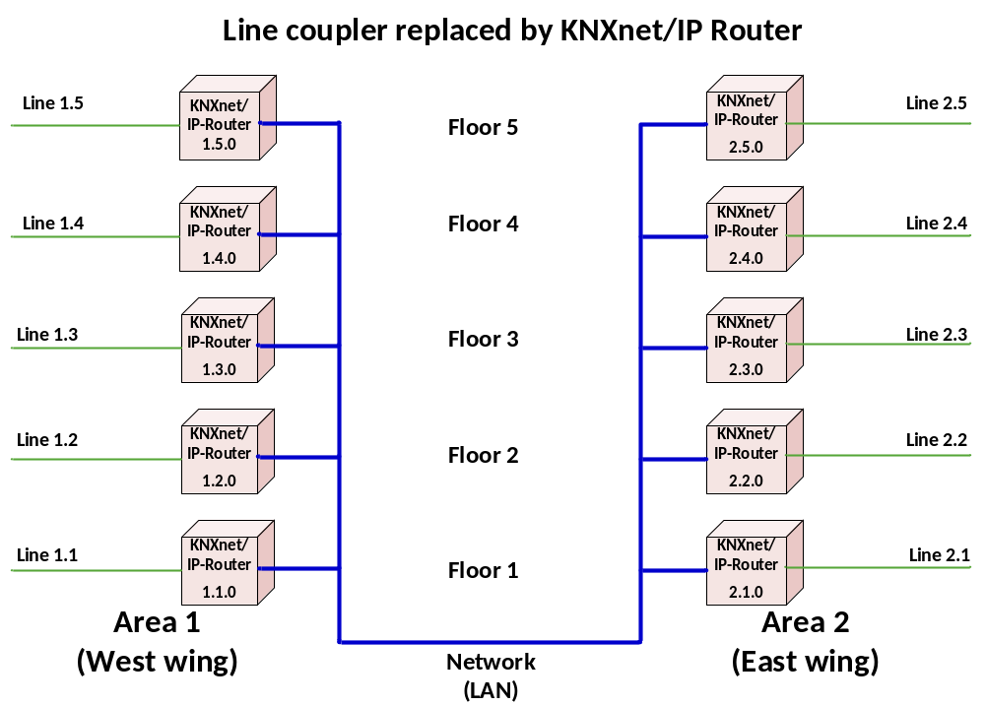
Figure 19: Our picture again: line couplers have been replaced by KNXnet/IP routers. This picture represents the underneath explained case 1.
The KNXnet/IP router can be used as a line coupler as well as a backbone coupler. If the KNXnet/IP router replaces the line coupler, all main lines and basically also the backbone line are replaced by Ethernet (Case 1).
If backbone couplers are replaced by KNXnet/IP routers, the normal line couplers can remain, as only the backbone line is replaced by Ethernet (Case 2).
Which case is more appropriate depends more or less on the - to be expected telegram rate requirements on main – and backbone lines. Theoretically, a third case is possible, as a combination of case 1 and 2, with normal TP areas with a KNXnet/IP router on top and also with lines with IP routers instead of line couplers. This option should however be chosen in exceptional cases. The topic is described in more detail in the KNX advanced course.

Limits to the use of KNXnet/IP routers
Even if the high bit rate of Ethernet considerably facilitates heavy telegram traffic and minimizes telegram loss, one should warn not to thoughtlessly program bus devices sending out telegrams too frequently. The fast Ethernet will not help if for instance telegrams are sent out simultaneously from all lines into one single line. To explain it with a metaphor: the case would be similar to all cars accessing a 1.000 lane motorway via 100 entries but all of them also wanting to exit via a single lane exit. This is by the way not a KNX related problem: it is common to all mesh structured data networks.
Only a meaningful organisation of communication between bus devices and lines will be able to prevent a very unlikely but still possible loss of data.
This however should be easily possible if one has sufficient knowledge on bus devices and their respective parameters.

Informative annex - old line coupler type

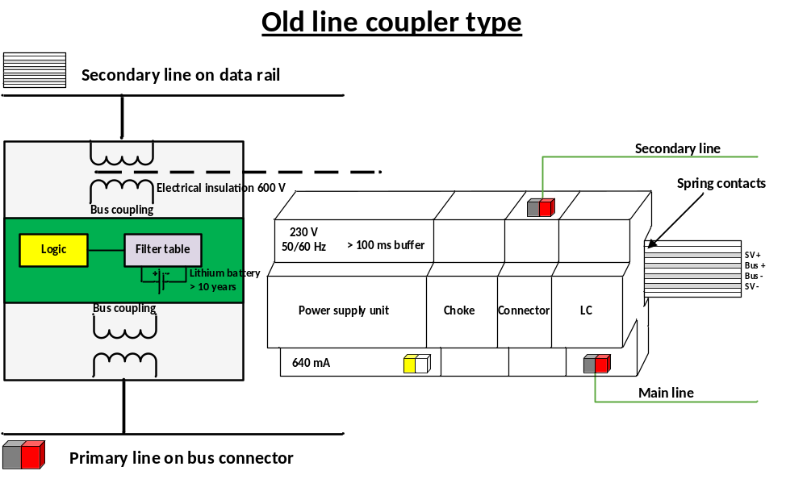
Figure 20: Block Diagram: old line coupler type

In earlier installations (until June 2003) line couplers were installed where power supply for both bus coupling units, logic and the filter table memory were supplied from the secondary line.
The primary line of this type of coupler, which is 4 or 1 unit wide, is connected via standardized bus connectors and the secondary line by means of a data rail (spring contacts). The connection to the bus cable is established by means of a data rail connector (2-pole or 4-pole).
A lithium battery (with a life span of more than 10 years) provides the backup supply for the memory containing the filter table, also in the case of a bus power down. New line couplers are equipped with a flash ROM memory and therefore do not need backup battery power.

This chapter assumes the use of centralized power supply units only. For decentralized power supply units, consult chapter “Installation”.
Newer couplers (from 2019) may also decrement this value.

