KNX Bus Devices

Table of Contents
1 Introduction 4
2 Data stored in a KNX device 6
3 System profiles 7
3.1 General 7
3.2 Detailed description of the above features 7
3.2.1 Access control 7
3.2.2 KNX Serial number 8
3.2.3 Interface objects 8
3.2.4 Memory size 8
4 Classical application functions 9
4.1 Dimming with start/stop telegram 9
4.2 Dimming with cyclical telegrams 10
4.3 Application function: 'dimming actuator' 11
4.4 Application function: drive control sensor 12
4.5 Application function: drive control 13
5 Drive control object structure 14

In this chapter, the following abbreviations are used:

PEI = Physical External Interface
BCU = Bus coupling unit
AM = Application module
TRC = Transceiver
SR = Shift register
DAC = Digital-Analogue Converter

Introduction
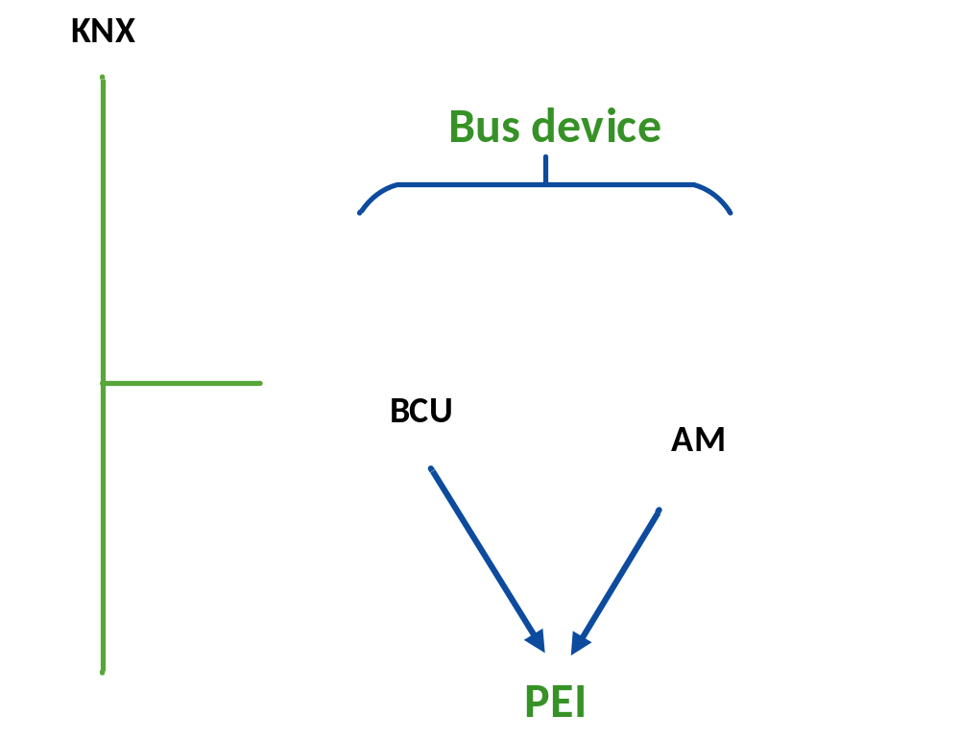
Figure 1: Bus device
A functioning bus device (e.g. dimming/shutter actuator, multi-functional push button, fire detection sensor…) principally consists of three interconnecting parts:
- bus coupling unit (BCU)
- application module (AM)
- application program (AP)
Bus coupling units and application modules are offered on the market either separated or built into one housing. They must however always be sourced from the same manufacturer. When separated (sometimes and then mainly the case for flush-mounted products), the application module can be connected to the BCU via a standardised or a manufacturer-specific Physical External Interface (PEI). This PEI serves as
- an interface to exchange messages between both parts
- the power supply of the application module
Whether the application module and bus coupling unit fit together – also whether they can be connected mechanically – has to be checked with the respective manufacturer.
In the early days, a BCU could detect whether the application module stuck on it matched the loaded application program, by the measurement of a specific resistor of the application module over the PEI interface and comparing it to the PEI type of the loaded application. In the case of a mismatch, the loaded application program could be stopped.
These days manufacturers may opt for manufacturer specific mechanical coding to ensure that only the proper application module is stuck on (their) BCUs or build integrated devices (where such a check is not needed).
In case of TP devices, the connection to the bus is mostly ensured via the standardised bus connector (dark grey/red). In case of DIN rail devices, connection to the bus is in rare cases also ensured via contact blocks to a so-called data rail (see chapter “Installation”).
Inside an integrated KNX product, from an electronics point of view, there is mostly
- an electronic circuit (mostly chip) taking care of the coupling function to the respective medium (responsible for the sending and receiving of telegrams), called ‘transceiver’;
- a microcontroller running the system/operating and application software and
- an electronic circuit taking care of the application function.
In some (rare) cases, the medium coupling function is separated as a bus coupling unit, in other cases the medium coupling function and the microcontroller form a BCU. In most cases, all electronics form an inseparable unit.
Each bus device has its own intelligence thanks to the integrated operating system and program memory: This is the reason why KNX is a decentralised system and does not need a central supervising unit (e.g. a computer). Central functions (e.g. supervision) can however if needed be realized via visualisation and control software installed on PCs.
On the KNX product or the BCU, in most cases a programming button and a programming LED can be seen: the button is operated to put a BCU or the product in programming mode (to assign the individual address). The LED signals if the programming mode is on or off.
BCUs are currently available for connection to two different media: Twisted Pair (Safety Extra Low Voltage) and RF (KNX-RF).
Depending on their main function, bus devices can basically be divided into three classes: sensors, actuators and controllers. It is rare to have devices with pure sensor or actuator functionality nowadays. E.g., each push button with LED status display also has an “actuator” function and each actuator with status information has a “sensor” function.
- In the case of a sensor, the application module transfers information about its actual inputs (digital / analogue) to the BCU. The latter codes this data and sends it on the bus. The BCU therefore regularly checks the state of the inputs of the application module.
- In the case of an actuator, the BCU receives telegrams from the bus, decodes them and passes this information on to the application module, which then controls the actual available outputs (digital / analogue).
- A controller regulates the interaction between sensors and actuators (e.g. logical module) and has no physical inputs and outputs.

Data stored in a KNX device
Inside the memory of a KNX device, the following data is stored:
- The system software: over the years, KNX and its manufacturers have standardized different versions of the system software (or “system stack”, say “KNX operating systems”). These different software profiles are identified towards the ETS by means of a “mask version” or “device descriptor type 0”. The mask version consists of 2 bytes and cannot be changed in the device. When downloading a device, the ETS checks this system software version to be able to make out how the device needs to be configured. Further information on these system profiles is given in clause 3.
- Temporary values of the system and the application: These are lost when there is a bus power down (if not stored earlier in non-volatile memory by the device).
- the application program, the individual addresses, group addresses or parameters: these are usually stored in rewritable memory.
In the case of S-mode compatible devices, the installer searches the matching ETS™ product entry via the KNX Online Catalogue and then downloads it into the device, in this way determining the function of the product. An S-mode compatible KNX push button mounted on a BCU can only generate dimming signals, after the suitable application program has been programmed into the device via the ETS.
The manufacturer code of the application program and the bus coupling unit must match to be able to load the application program.
In the case of E-mode devices, the device reports the supported functionality (as regards supported “Easy” channels) by means of the device descriptor 2, indeed a different device descriptor than S-Mode devices. A device is normally shipped with loaded application program. The linking of such KNX devices and the setting of the relevant parameters is ensured either via appropriate hardware settings or via a central controller.

System profiles

General
The System 1 technology was introduced with the first generation of KNX devices (in 1991), but is still part of the KNX Standard and can still be used in new devices.
A few years later in the nineties products based on System 2 and System 7 were introduced. System 7 was then further developed to System B in order to get rid of the limitations with regard to the number of group objects and group addresses.
The table below gives an overview of the most important features of these KNX system profiles:
 | System 1 | System 2/7 | System B
Mask version or device descriptor type 0 | E.g. 0012h | E.g. 0025h, 0705h | E.g. 07B0h
Maximum number of group objects | 12 | 254 | 65536
Support of interface objects | No | Yes
Support KNX serial number | No
Support access control | No
Application programs designed for System 1 technology can also be loaded into certain
System 2 devices (upwards compatibility).

Detailed description of the above features
The features of System 2, System 7 and system B outlined above are explained here again in detail:

Access control
When a tool wants to access memory of System 2, 7 and B devices (reading and/or writing), it must first authorise itself by means of an authorisation key of 4 byte.
Keys can be defined at various levels, some of the levels are restricted for manufacturer access (and can hence not be accessed by integrators), one level however gives access to not system related memory in the devices and can be locked by entering a BAU password in the project properties. If this BAU password is lost, access to the device is no longer possible.
Access control is never needed for normal communication via group addresses. In this case, access is always possible.
Some System 2/7/B devices – even if entering a BAU password in ETS – still allow access to the memory with any key.
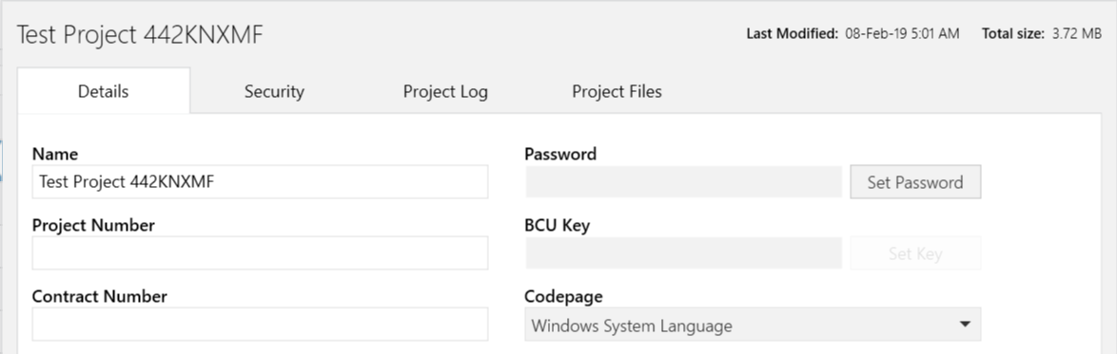
Figure 2: entering a BCU key in the project details in ETS

KNX Serial number
System 2, 7 and System B devices have a KNX serial number: this number, which is assigned to each device before leaving the factory, allows writing or reading the individual address of a device without having to press the programming button of the device. This feature is however not yet supported by default in ETS, but some of the available ETS Apps in the MyKNX shop allow to do so.

Interface objects
Interface Objects contain certain system and application properties (e.g. address table, parameters …), which can be read and/or written by a tool (e.g. ETS during download) without explicit knowledge of the device’s memory map.
The ETS end user (= integrator) cannot manipulate such objects but can read them by means of the ETS “Device Editor” App. More in-depth system knowledge explained during the tutor course is required in order to do this kind of manipulation.

Memory size
When looking at the number of group objects and group addresses one can see that the memory size increases with the listed mask version: the memory of system 2 is bigger than 1, and 7 is bigger than 2, especially for profile “B”.
For more than 10 years, 255 group objects were considered as a large number but with the development of new touch panels, application controllers and gateways, this number became too small again. That is why system 7 was extended with 1 byte as regards number of addresses and objects. Because of this, 65536 and 65535 have now become the maximum values, normally not reached by current applications. In other words, this is s a pure theoretical value, especially when one compares this to the total possible address capacity of a KNX system (which is just as big).

Classical application functions

Dimming with start/stop telegram

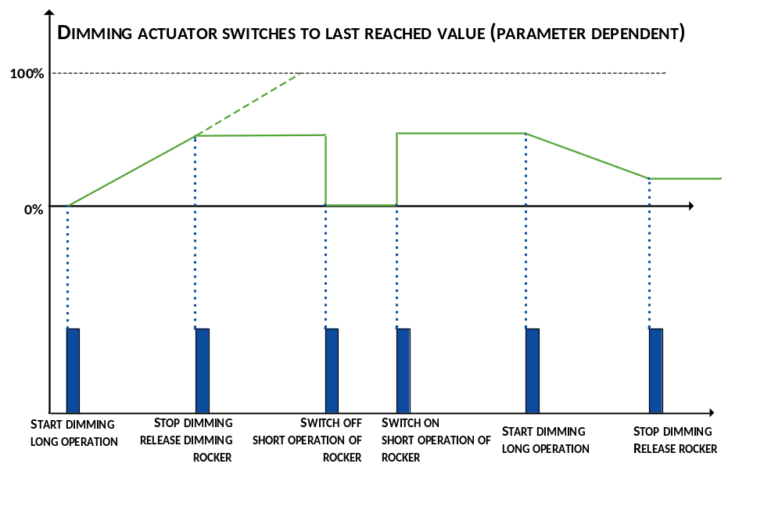
Figure 5: Dimming with start/stop telegram
The duration of the rocker operation determines whether the switching function or the dimming function via the same rocker is activated. If the time the rocker is pressed is shorter than the time parameterized in the application program of the push button (e.g. < 500 ms), a switch telegram is transmitted. If one operates the rocker longer than the time parameterized, a 'start dimming' telegram is transmitted. As soon as the rocker is released again, a 'stop dimming' telegram is transmitted.
Different group addresses are used for the switching and dimming telegrams to ensure that the dimming actuator executes the correct functions.

Dimming with cyclical telegrams
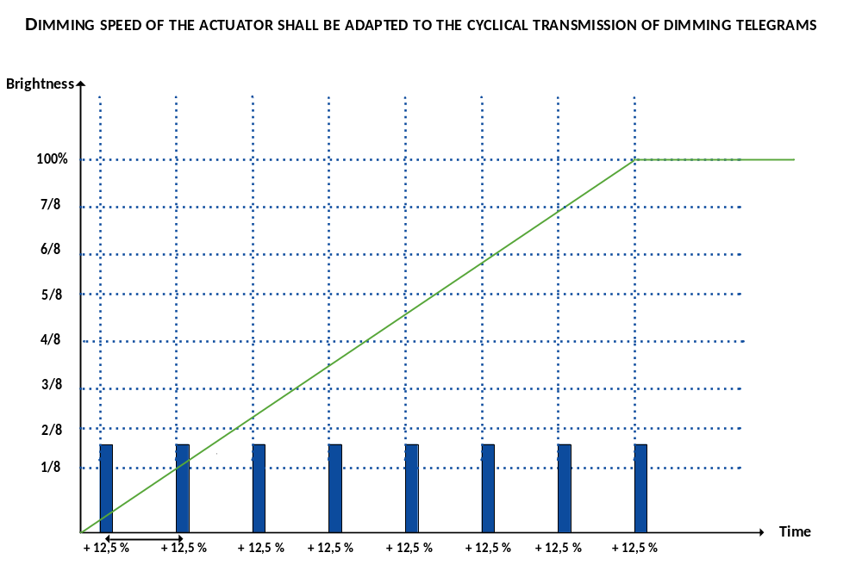
Figure 6: Dimming with cyclical telegrams
In a system controlled by wireless remote controls, e.g. infrared senders, the transmission signal might be interrupted as somebody passes through the IR beam. In order to avoid a situation where the dimming actuator does not receive important telegrams (e.g. the stop telegram), in most cases one will choose the setting 'cyclical dimming' during parameterisation of a remote control. The transmitter in these settings transmits the telegram “increase brightness by 12,5 %”. The consequences of losing such a telegram are not as serious as the loss of a stop telegram, which is only sent once (as was explained in clause 4.1).

Application function: 'dimming actuator'
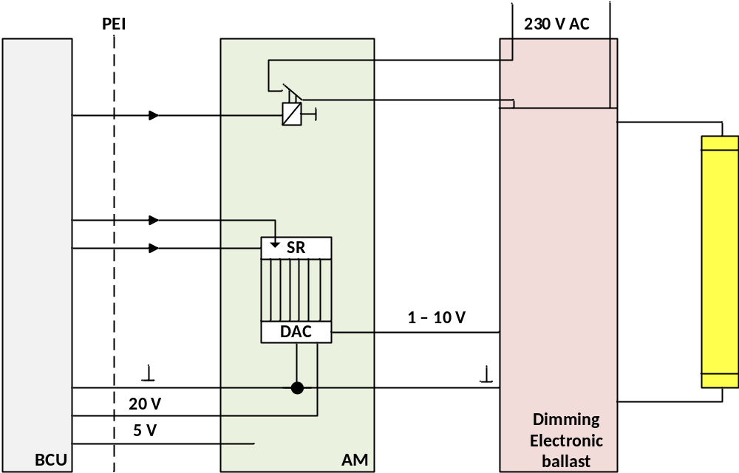
Figure 7: Application function: 'dimming actuator'
The counterpart to the sensor function dimming is the dimming actuator. There are various types of dimming actuators, depending on the dimming concept and the lamps or the ballasts used. In this example, a passive 1 – 10 V analogue interface is shown. But, all dimming actuators have something in common: They have a parameterized dimming speed. The dimming speed is therefore an exclusive matter of the actuator!
In the example shown above, the BCU transmits a control signal to the application module. This signal has to be electronically adapted to the control input of the electronic ballast. The dimmer's electronic ballast uses the voltage to control the light emission of a fluorescent tube. The relay in the application module is used to (dis)connect the mains voltage.

Application function: drive control sensor
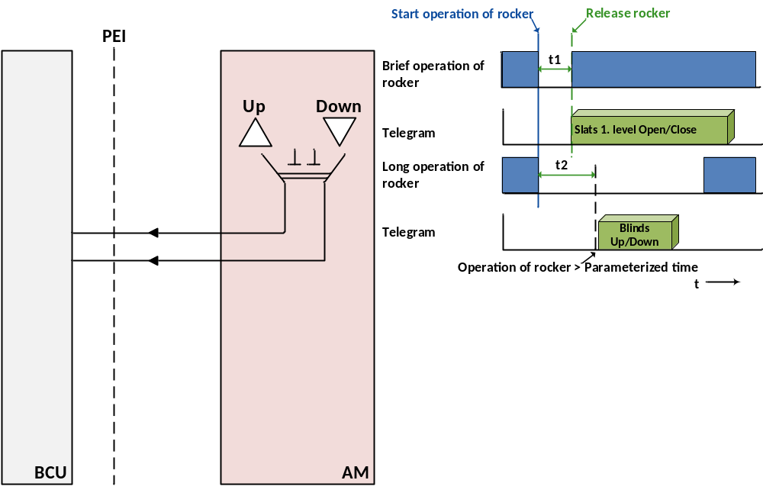

Figure 8: Application function: drive control sensor
The blinds but also the shutter operation functions similarly to the dimming operation: A distinction is made between a brief and a long operation of the rocker.
The time t2 (e.g. 500 ms) acts as a "boundary" between the commands “slats step open/close” and “blinds up/down”.
T1 is the debouncing time that can be set for push button interfaces and binary inputs. For push buttons there is normally no debouncing time.
An important difference with dimming is however, that if one releases the rocker once the drive has started, the drive will continue to work until one has again shortly presses the rocker.
This makes sense as blinds / shutters have basically much longer travel times compared to the time a dimming actuator needs for to dim up to 100 %.
The short operation of the rocker has also two different implications – when the drive is not in motion, it will cause a moving of the slats (only meaningful for blinds with adjustable slats). When sending the step command to a moving drive, this will cause the drive to stop. This shows that in any case for blinds control both commands i.e. shorter or longer operation of rocker are required, also when there is no need to adjust the slats.

Application function: drive control
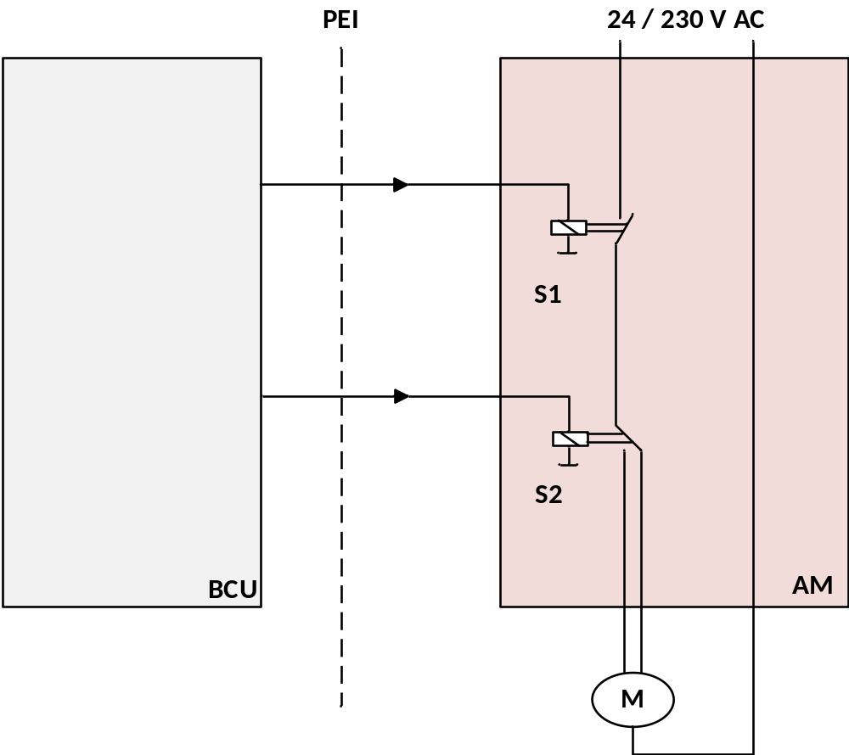
Figure 9: Application function: drive control
Depending on the telegram received, the BCU passes on the command “up” or the command ”down” to the relay S2. On receiving the telegrams “slats open/close 1 step”', the BCU energises the relay S1 for the appropriate duration. If the motor was already switched on, this telegram halts the blind (S1 opens). On receiving the telegram “blinds up/down”, the BCU energises the relay S1 for a period longer than the total time the blind is in movement from the very top until the very bottom and vice versa. As usual, the limit switches of the blinds bring the motor to a halt when the limit position is reached, even if there is still voltage at the motor.
A blind actuator never has the task to take care of the safe deactivation of the blinds. This always needs to be ensured by the device itself in order to guarantee interlocking!

Drive control object structure
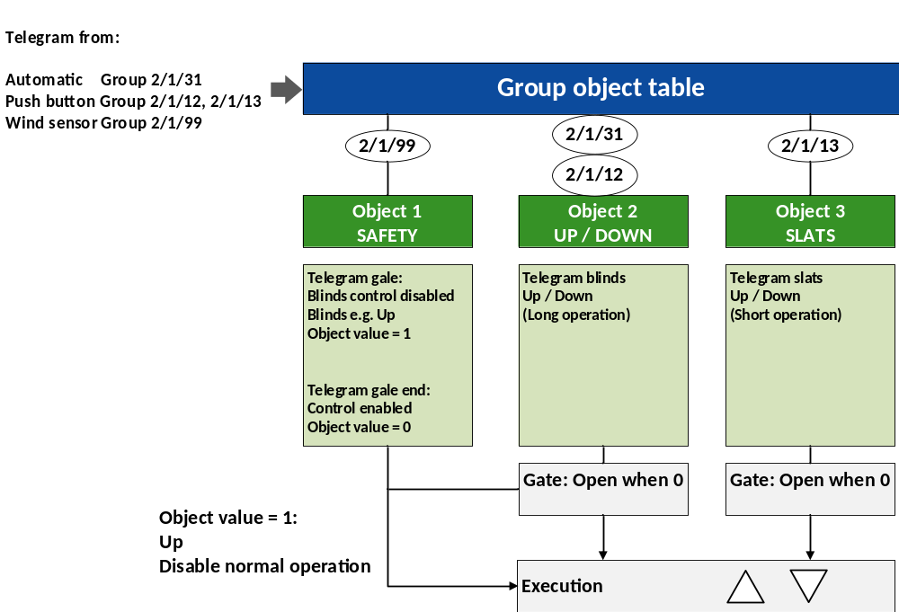

Figure 10: Drive control object structure
The figure above shows the basic functionality of a blind actuator. Apart from the normal operation, each blind/shutter actuator can for instance have a safety function.
If, for example, the sensor responsible for measuring the position of the sun triggers the telegram “blinds down” using the group address 2/1/31, the object group "up/down" is addressed and the corresponding command is executed.
Brief operation of the push button transmits the 2/1/13 telegram “adjust slats” and long operation of the key sensor sends the 2/1/12 telegram “open/close blinds completely”.
Telegram 2/1/99 triggered by the wind sensor addresses the object group “safety”. If a gale is developing, telegram 2/1/99 orders the blinds to go up/down (depending on the parameterization) and disables any further operation. When the storm has eased off, a telegram is sent that enables blind operation again. The de-activation of the alarm does not mean that the actuator is lowering the blinds again by itself (in the position before the gale). This makes no sense as the actuator has no information about the duration of the alarm or whether the blind really has to go down again.
New actuators have of course a variety of further functions and group objects, which cannot be explained during the basic course due to time constraints. These more complex functionalities, e.g. weather station, are explained in detail in the KNX advanced course.

The actual number of available group objects or group addresses which can be assigned depends on the used microcontroller

