KNX RF

KNX Association

Table of contents
1 Introduction 3
2 The RF transmission medium 3
3 Transmission technology 6
3.1 KNX Ready (single-channel solution) 6
3.2 KNX RF-Multi (multi-channel solution) 8
3.3 Bus access 9
3.4 Telegram structure and addressing (informative) 10
3.5 Structure of the bus devices 12
4 Topology 13
4.1 General 13
4.2 Combination of transmission media 14
5 Commissioning and specific checks 15
5.1 Checking the installation 15
5.2 Commissioning and programming the functionality in E-mode devices 15
5.3 Commissioning and programming the functionality in RF S-Mode devices 16
5.4 Functional test and test report for RF E-mode devices. 17

Introduction
KNX RF allows the wireless transmission of telegrams by means of the medium Radio Frequency. It is therefore not required to install a separate bus cable. KNX RF is very interesting if an existing TP installation has to be extended and no additional cables can be installed due to local building regulations, aesthetical reasons etc. (e.g. in museums, public buildings etc.).
In order to guarantee the correct functioning of KNX RF systems, the basics of the RF medium and especially the structure of KNX RF will be treated in the following chapters.

The RF transmission medium
The range of KNX RF components is indicated as free-field range. The free-field range is significantly higher than the achievable distance within a building.
Due to the maximum allowed transmission power and the limitation of available energy for the transmission in case of battery-operated or battery-free (e.g. operated by solar energy) devices the free-field range is limited to approximately 100 m.
Radio frequency signals are attenuated on their way from the transmitter to the receiver by many factors. The real operating range within buildings is therefore reduced. KNX RF uses the 868 MHz frequency band.
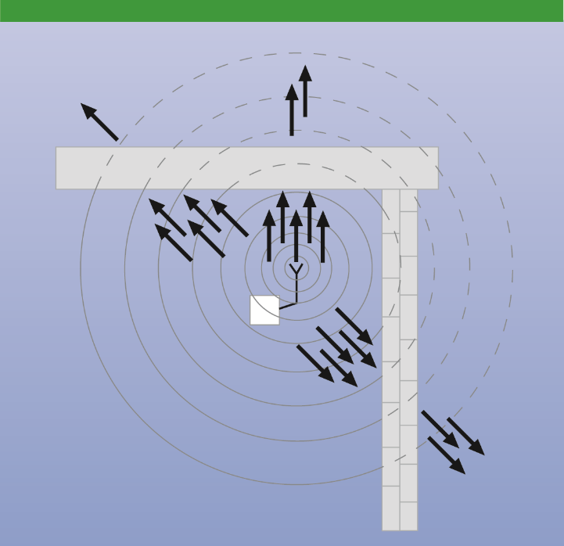
Figure 1: Attenuation by walls and ceilings depending on the material and the wall thickness
The radio signals do not pass through walls, ceilings and furniture without hindrance but are attenuated during penetration and also partially reflected. Metallic objects shield or reflect the radio signals and radio shadows are produced on their reverse side, in which direct reception is not possible.
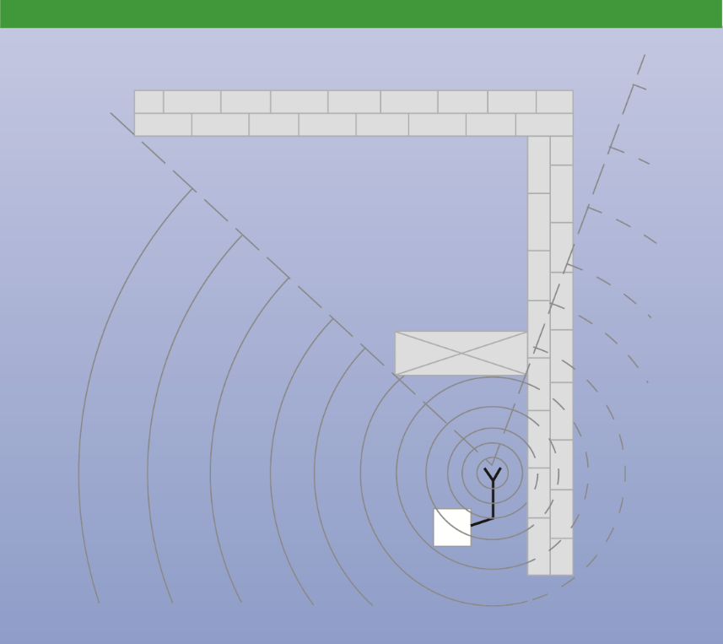
Figure 2: Radio shadows by metal walls, doors or cabinets
Reflections can have both a positive and a negative effect. Reflections have a positive effect in areas in which no direct reception is possible. Reflections are disruptive when both a reflected signal and a direct signal coincide in a radio receiver. Due to the different propagation times of the two signals received via the different routes, the resulting common signal can be weakened compared to the directly received signal.
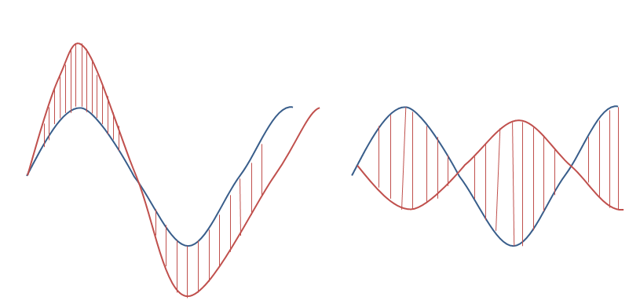
Negative reflection:
Signal reversed by reflection

Positive reflection:
Signal amplified by reflection

Figure 3: Consequences of reflections
Interfering factors due to structural or other spatial conditions must be taken into account during the building planning stage. The mounting sites for the RF devices must therefore be carefully selected under these considerations. If the installation sites cannot be freely selected, a good radio connection is achieved in most cases by using a KNX RF repeater.
In the case of mains-operated KNX radio devices, it must be ensured that the mains voltage is available at the selected mounting sites.
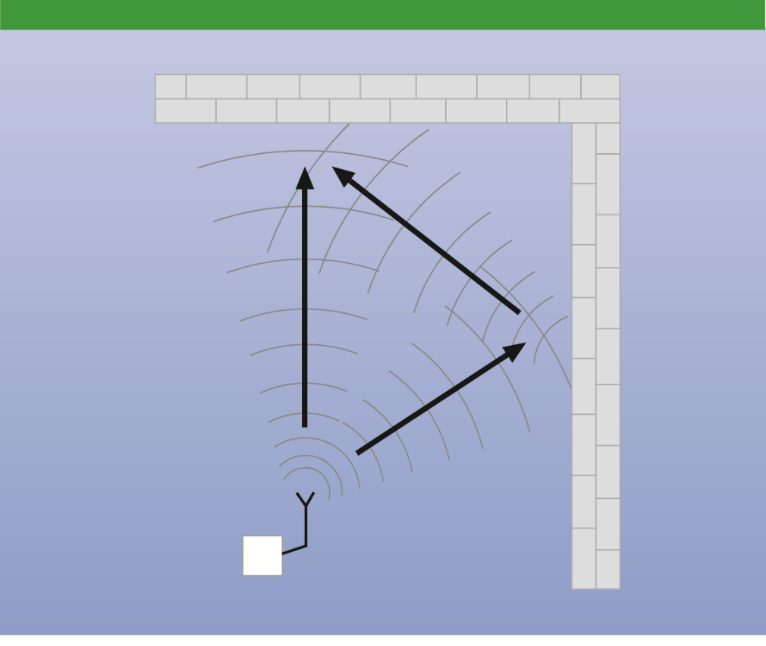
Figure 4: Signal attenuation and amplification by reflections

Transmission technology

KNX Ready (single-channel solution)
In radio technology, the information to be transmitted is modulated on a carrier. This can be either the amplitude (amplitude modulation), the frequency (frequency modulation), the phase angle (phase modulation) or a combination of these. This modulated carrier is transmitted to the RF receivers and the received signal is demodulated i.e. the information is recovered from the signal.

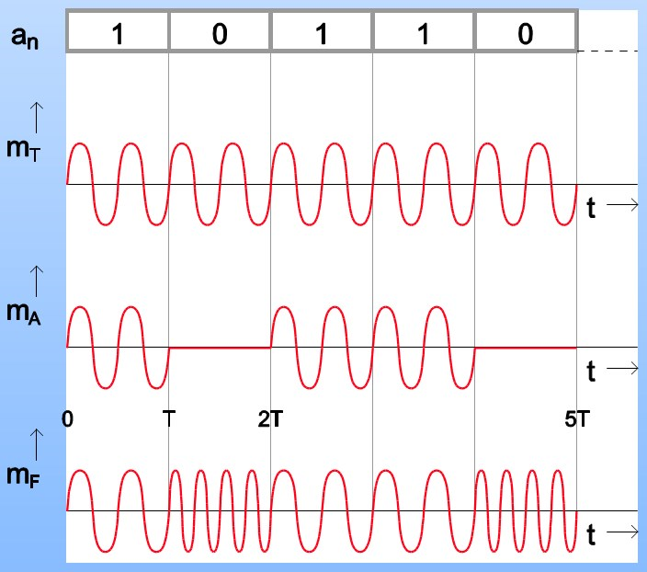
Information signal
(Baseband signal)
Carrier

Amplitude Shift Keying

Frequency Shift Keying
(KNX RF)
Figure 5: Types of modulation
In the KNX RF system, the frequency modulation or Frequency Shift Keying (FSK) is used as the modulation process. The logic states “0” and “1” are generated by a slight deviation in the carrier frequency, also called middle frequency. In KNX RF system, 868.30 MHz is used as the middle frequency. The transmission rate or bit rate of the information to be transferred is 16,384 bits per second and is modulated according to the Manchester coding. The advantage of the Manchester coding is the increased transmission reliability. With this coding, a change in the pulse edge from “0” to “1” or vice versa is performed in the center of each information bit.
Transmitters and receivers can be synchronized very easily with this coding as the 0/1 or 1/0 transition in the centre of each to be transmitted bit enables a continuous adjustment of the clock pulse.
The transmission frequency of the KNX RF system is situated in the ISM band (Industrial-Scientific-Medical). The frequency ranges for different applications within this band are precisely defined.
The maximum transmission power is 25 mW. The radio transmission interval of each device, also called duty cycle, is 1 % (maximum transmission duration of 0.6 seconds per minute). Thanks to the fixed transmission time, it is ensured that there are no individual continuous transmitters and therefore no continuous interference signals exist, that can block the radio channel.
It can therefore be assumed that transmitted messages can also be received and evaluated by the corresponding receiver.
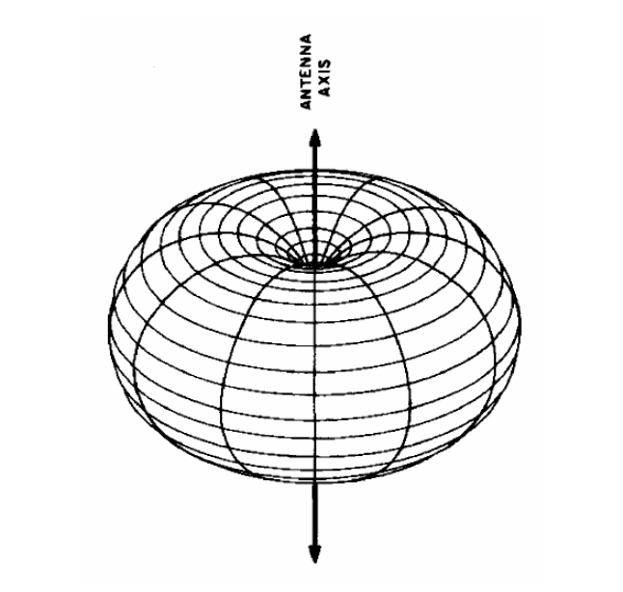
Figure 6: Propagation of radio waves

The principle structure of a transmitter and a receiver is shown in the figure below.
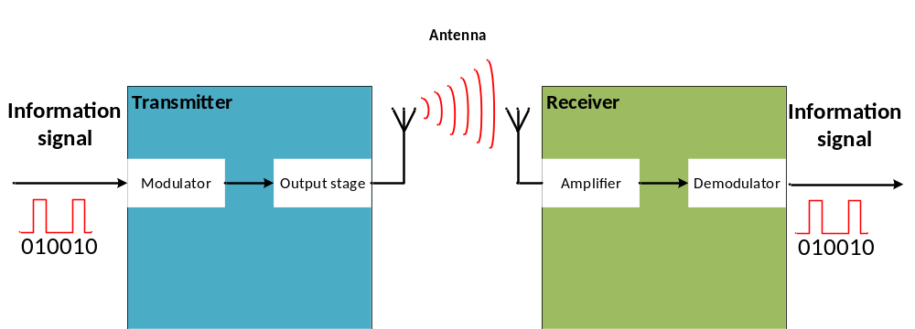
Figure 7: Block diagram of a KNX radio transmission

KNX RF-Multi (multi-channel solution)
Single-channel radio communication can be disturbed by other RF systems in the same or neighboring frequency bands (e.g. by continuously sending devices, by devices having a higher transmitting power, by a defective device, by superimposing of signals…).
In order to counter such disturbances, there are besides KNX Ready devices with only one channel, KNX RF-Multi solutions, which can transmit their information over several channels. These solutions dispose of several fast and slow channels.
The devices can hop from one occupied channel (e.g. F1) to one or more further channels (e.g. F2 and F3).
The fast channels are intended for applications such as lighting, shutters etc., which are directly controlled by human beings.
The slow channels are intended for devices, which do not have to be in receiving mode continuously, like e.g. HVAC-control devices.
Fast channels have a data rate (also called transmission rate) of 16.384 kbps, whilst slow channels only have half that speed. The transmission rate (duty cycle) can vary in each separate channel.
The transmission rate in the fast channels F1 and F2 lies at 1 % or at 0.1 % when transmission power is maximum 25 mW. On the other hand, it can be increased to 100 % at maximum 5 mW for the fast channel F3 and the slow S1-channel (the transmission rate has to be however at 1 % when transmission power is between 5 and 25 mW).
The transmission rate in the S2-channel is limited to 10 % with a maximum transmission power of
25 mW.
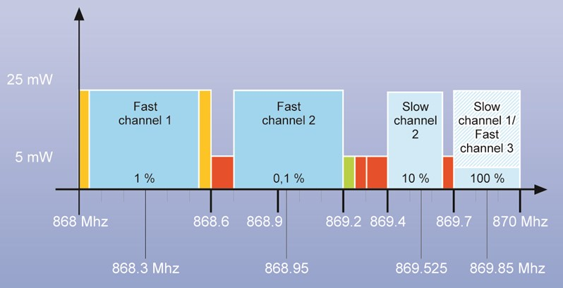
Figure 8: KNX RF-Multi different channels and allocated frequencies
In order to reduce the energy consumption of a device up to 80 % for fast channels and even up to
99 % for slow channels, the device will be put in sleep mode. To be able to receive telegrams it will be periodically woken up.
In order to ensure compatibility between single-channel and multi-channel devices, a compatibility scheme was laid down and newly developed single-channel devices must use a longer preamble. Multi-channel devices shall be downgradable to single-channel devices.
The multi-channel approach increases the likelihood of a successful transmission. On top of that, it allows the verification of the correct reception by supporting a rapid immediate acknowledgment of up to 64 individual receivers (Fast IACK or Fast Immediate Acknowledgement). In case a Fast IACK is missing, telegrams are automatically repeated. KNX RF Repeaters collect and pass on such confirmations, so that a verification of a reception is possible over longer distances.
KNX RF also checks, whether a radio transmission is already ongoing, before starting an own transmission: in this way, the number of possible collisions is considerably reduced.
KNX RF in general natively supports long frames. This is necessary to be able to support the KNX Secure Application Layer (used for security applications), which can also be used by other KNX media. This allows authentication and encryption. In this way, the media coupler does not constitute the weak point in the security concept. As such, KNX RF devices can be used for applications such as metering, access control, fire alarm, etc.

Bus access
Unidirectional devices send a telegram immediately if required. In case of a collision, the telegram has to be sent again. Due to the duty cycle of 1 % it is nearly excluded, that collisions occur.
Bidirectional devices check whether the radio channel is free before sending a telegram. If the channel is occupied, the device waits until the radio channel is free and then sends the telegram.

Telegram structure and addressing (informative)
Synch.
Data block 1
Checksum
Data block 2
Checksum
Data block 3
Checksum
Synch.
Telegram

Figure 9: Structure KNX RF telegram
A KNX RF telegram consists of several data blocks separated by checksum bytes. The data blocks contain the actual useful information (e.g. a switching or dimming command) and bus-specific information used for addressing.
The blocks at the start and end of the radio telegram are used to synchronize the receivers to the transmitter.
Control field
KNX serial number or domain address
Checksum
Data block 1

Figure 10: First data block
The first data block consists of the control field (4 bytes), the KNX serial number of the device or the domain address to which the device is assigned (6 bytes) and the cyclic redundancy check (CRC 2 bytes). The control field contains information about the telegram length, type of device (unidirectional or bidirectional), the transmission quality (signal strength) as well as the battery status of battery-operated radio devices.
In the case of E-Mode RF devices, the KNX serial number is sent after the control field.
The KNX serial number is a unique device identifier programmed into the device during manufacturing and is not modifiable. It is included in each telegram and stored in the receiver as a source address of the transmitter: this is done during commissioning or when linking the devices via RF. The KNX serial number is not only used for addressing the bus devices but also for separating the devices in adjacent KNX radio installations.
In the case of RF S-Mode devices, a domain address is sent after the control field. The domain address is included in each telegram and stored in the receiver: this is done during commissioning with the ETS. The domain address is also used for separating the devices in adjacent KNX radio installations.
The receiver detects via the cyclic redundancy check (CRC) whether a telegram has been transferred without any errors.
Control field
Individual address
Destination address
Data block 2
Control field
Data
Checksum

Figure 11: Second data block
In addition to further control and checksum bytes, the second data block contains the individual address, the destination address and useful information. The individual address is the physical address of the device. It is only required when programming the devices via controllers, couplers or ETS. It is automatically assigned during commissioning for KNX RF E-Mode devices or by ETS according to the wishes of the installer for KNX S-Mode devices.
The destination address differs in its function dependent on the access to the device to be addressed. In the case of physical addressing i.e. during programming, the destination address is the individual address of the device. During normal operation (e.g. when transmitting a switching command), the destination address contains the number of the addressed group object in a device for E-Mode devices or the group address assigned by ETS for RF S-Mode devices.
The useful information contains the data to be transferred such as commands, messages, parameters, measured values etc. Further data blocks can be transmitted in a KNX RF telegram depending on the length of the useful information.

Structure of the bus devices
KNX RF devices are available in flush-mounted, surface-mounted and built-in versions.
The flush-mounted devices mostly consist of equipment for switching or dimming lights, for controlling shutter drives or mains equipment on which push buttons for operation are clipped on. The RF communication part can then be integrated in the mounted surface or in the device itself.
As surface-mounted or built-in versions, various sensors, actuators or combined devices are available, which can be mounted, glued or built into various locations and surfaces.
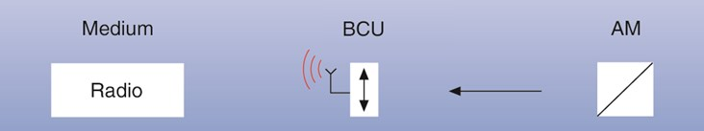
Figure 12: Principle structure of KNX RF

In the case of KNX RF components, the classic separation between bus coupling unit (BCU), application module (AM) and loadable application software in most cases does no longer exist. They are complete devices, in which the application software is preloaded in case of E-Mode devices or loaded by the ETS in case of S-Mode. According to their function and application, the devices are designed as unidirectional or bidirectional radio transmitting devices.

Unidirectional devices can either only send or only receive. Only sending devices are mainly battery-operated sensors or detectors such as hand-held or wall-mounted transmitters, binary inputs and door/window contacts.
Bidirectional devices can both send and receive i.e. they can be sensors and actuators at the same time.
The KNX RF repeater is also a bidirectional device, which takes over the automatic routing of RF telegrams in order to increase the RF coverage of an installation. This can take the form of a stand-alone unit in a wide variety of models or it can be functionally integrated in a bidirectional actuator.
Media couplers are used to connect KNX RF to KNX TP.

Topology

General
The devices in a KNX installation using radio transmission are not subject to any type of hierarchical arrangement. They can practically be installed in any location and if within radio range, each sensor can communicate with each actuator.
The radio transmission medium range cannot be determined precisely in spatial terms i.e. KNX RF telegrams can also be received by devices installed in adjacent KNX RF installations. Mutual side-effects, as a consequence of this must therefore be ruled out.
As part of the telegram, each KNX E-Mode RF device sends therefore its serial number as device identifier.
KNX RF S-Mode devices send their domain address as device identifier.
Only the receivers taught-in or linked to this transmitter or form part of the same domain, will evaluate its telegrams.
In addition to the necessary separation from adjacent KNX radio installations, the range of the radio signals in buildings is also limited by structural conditions such as walls, ceilings and furniture. The range can however be extended with up to 2 KNX RF repeaters, so that radio signals can also be transferred over several floors.
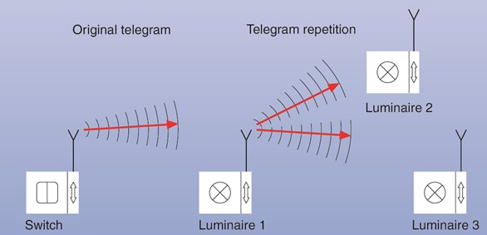
Figure 13: Repeater function in KNX RF: Luminaire 1 increases the range of the switch through telegram repetition.

Combination of transmission media
One of the big advantages of KNX is the possibility to use different transmission media (bus cable (TP), radio frequency (RF), IP) within one system. Therefore, a KNX system can only consist of pure KNX RF devices but can also be a combination of KNX RF with other media, like e.g. KNX Twisted Pair. Media couplers can be used to transfer information and commands from devices in one medium to devices in another medium. The media coupler can be additionally used as a “Repeater” in order to increase the radio range. It depends on the type of the media coupler how it is defined which telegrams shall be transferred. This can be made in two different ways:
- Only via ETS (for KNX RF S-Mode – comparable with the function of a line coupler (bus line to RF line))
- Via ETS and via the media coupler (TP and RF). In this case, the RF E-Mode devices which are to be connected, are “taught-in” into the media coupler via E-Mode, the necessary bus specific information is planned in ETS and then downloaded into the media coupler.
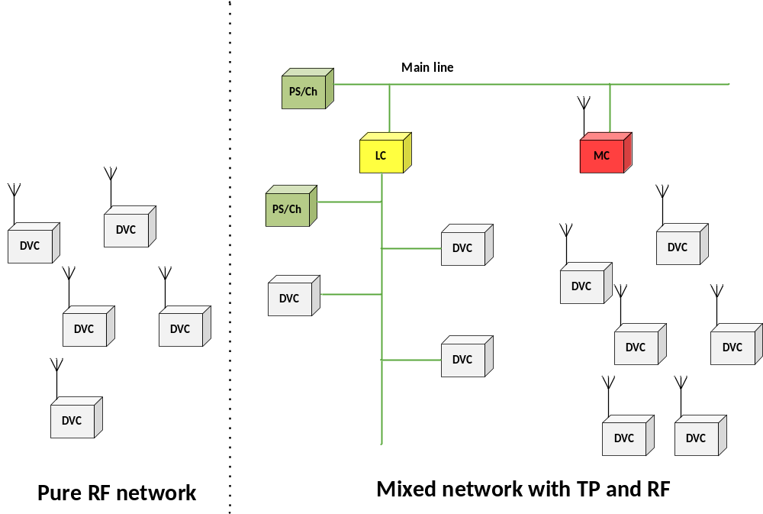
Figure 14: Topology of RF (MC = Media coupler)

Commissioning and specific checks

Checking the installation
After the installation of a KNX RF system, the tests applicable for low-voltage installations must be conducted. In principle, the regulations for the creation of mains power systems up to 1000 V are to be observed.

Commissioning and programming the functionality in E-mode devices
The commissioning of a KNX RF system i.e. the connection or teaching in of radio transmitters and receivers can easily be carried out. Usually this is made via DIP-switches or push button actions (E-Mode Push Button) after the mounting of the devices or by ETS. Both the actuator and the associated sensor are put into commissioning mode and the devices are taught-in via the sending of a connection telegram.
Which commissioning mode is applicable can be directly seen on the device label. The exact procedure can be found in the respective operating instructions of the products. Some device versions require additional tools such as a PC and software during commissioning.

2. Setup function of receiver
Configuration of lighting with buttons and LED-display
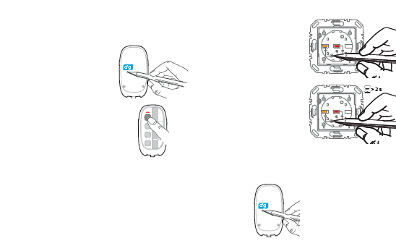
- Briefly press the cfg button on transmitter
The cfg-LED of transmitter and all receivers within radio range lights up
- Briefly press the push –button on the transmitter which should activate the function
The cfg-LED on transmitter flashes. Transmitter and receiver are in config-mode
- Briefly press the cfg button on transmitter again
The cfg LEDs on transmitter and all receivers go out
3. Finish configuration
- Briefly press the fct button on receiver until the desired function is displayed
- To confirm, hold the fct button pressed longer than 2 seconds
- Configmode of transmitter and receiver

Figure 15: Example for commissioning an E-Mode Push Button
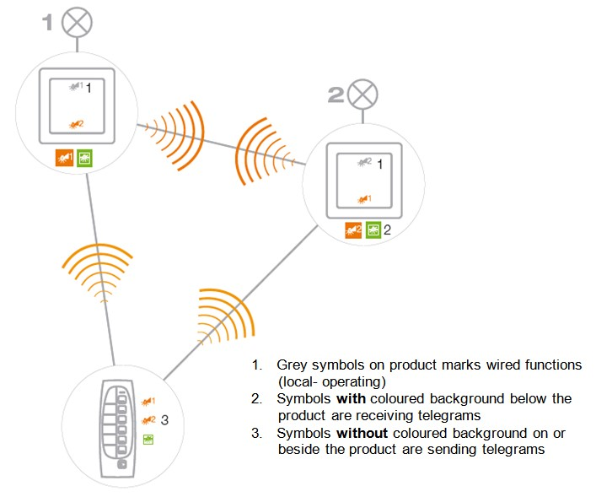
Figure 16: E-Mode communication

Commissioning and programming the functionality in RF S-Mode devices
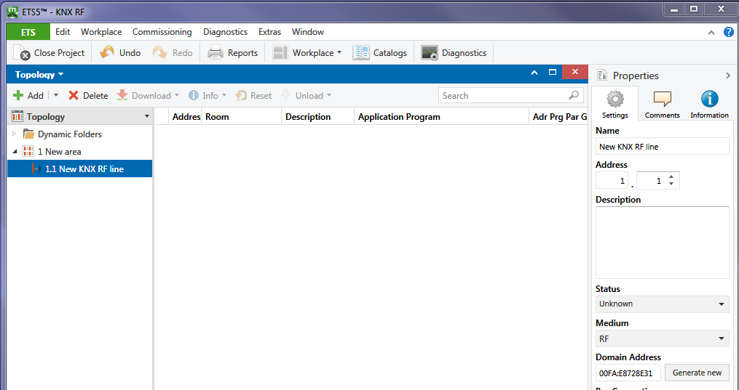
Figure 17: Domain address in ETS 5

In case of commissioning KNX RF S-Mode devices, the procedure is to a large extent similar to that of KNX TP S-Mode devices.
Each RF line gets a unique domain address.
The purpose of the domain address is to avoid interferences between adjacent KNX RF lines. Therefore, each KNX RF line gets an own domain address.
Also, here a KNX RF data interface is available for configuration and commissioning of KNX RF S-Mode devices directly from the PC.
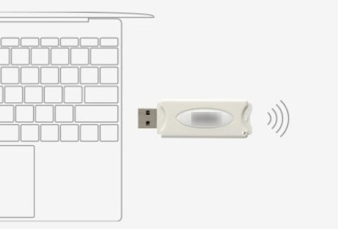
Figure 18: KNX RF data interface

Functional test and test report for RF E-mode devices.
In addition to a general check of the installation, a functional test of the entire installation must be carried out. All the functions and taught-in or configured radio connections between the sensors and actuators must be checked. The sensors must be triggered or pressed and the corresponding reactions of the actuators must be observed. For warranty reasons, the correct functioning of the installation must be documented and recorded in a test or acceptance report. As the connections between E-Mode sensors and E-Mode actuators can be changed very easily and the installation could no longer correspond to the originally ordered version, it is recommended to record this configuration in a list.

