KNX Commissioning ETS5

KNX Association

Table of contents
1 General 3
2 Commissioning 3
2.1 Commissioning requirements 3
2.2 Local or imported projects 4
3 Starting the commissioning 5
3.1 Bus access 6
3.2 Configuring the interface 7
3.3 Configuring the local device 10
3.4 Opening a project 11
3.5 Selecting a view 11
3.6 Downloading 13
3.7 Assigning individual addresses 14
3.8 Loading the application (application software) 15
4 Reconfiguration 16
4.1 Implementing project design changes 16
4.2 Reprogramming filter tables 17
4.3 Commissioning devices 17
5 Unloading devices 18
6 Resetting devices 19
7 KNX RF Commissioning 20
7.1 Adding a RF Line 20
7.2 Commissioning a KNX RF Line 22

General
All PL 110 information in this chapter is only for informative purposes. The PL 110 content is not part of the exam at the end of the basic course.

Commissioning

Commissioning requirements
The commissioning of a KNX installation does not necessarily require the complete set-up of the bus installation with all the bus devices. In larger projects (several building sections), it does make sense to pre-program e.g. bus coupling units in one’s office or in the workshop. Since it is not an absolute requirement during the commissioning stage for the complete data set to have been loaded into the bus coupling unit, it may be useful to already load only the individual addresses into the bus coupling units and the remaining relevant data when the bus coupling units have been installed in the installation. Regardless of whether the commissioning is carried out in the office, workshop or on the building site, the application modules of the flush-mounted devices should not yet be mounted, so that programming button and programming LED remain accessible. Special care has to be taken in case of “monoblock” devices where e.g. the mounting of the rocker cover plates which will cover the programming button should be done after successful commissioning. In distribution boards the cover plates have to be removed in such a way, that the programming buttons and LEDs of the KNX-devices are accessible. In case of built-in devices in lamps or in detached ceilings it makes sense, to download into these devices already in the workshop at least the individual address, because in most cases it will be difficult to access these devices later on.

The commissioning can be carried out via
- a USB interface
- or a network connection
of the commissioning PC. The required settings are explained in more detail under “Bus access” and “Configuring the interface”.

All functions in ETS can either be called from the menu bar or via the context menus (right mouse button). A large number of functions can also be started directly via icons in the toolbar. ETS thus behaves like the majority of programs running under the WindowsTM operating system. All subsequent screenshots only show examples. The functions do not necessarily have to be called in exactly the same way as described here. During the first steps with ETS, it is worthwhile to always choose the same course of action. For instance you could use the right mouse button as frequently as possible as it in many cases leads directly to the desired dialog. Also, here the context menu in the top level of the user interface offers an alternative.

Local or imported projects
The project of the KNX installation must be contained in the local data store for commissioning purposes. If the project has been configured on a different PC, you have the following possibility:

There is the option is to import the exported project with ETS onto the commissioning PC. The necessary steps are described in the “Project design” chapter. It is however necessary to ensure that all additional installed programs e.g. for touch panels, logic modules are also installed on the commissioning PC.

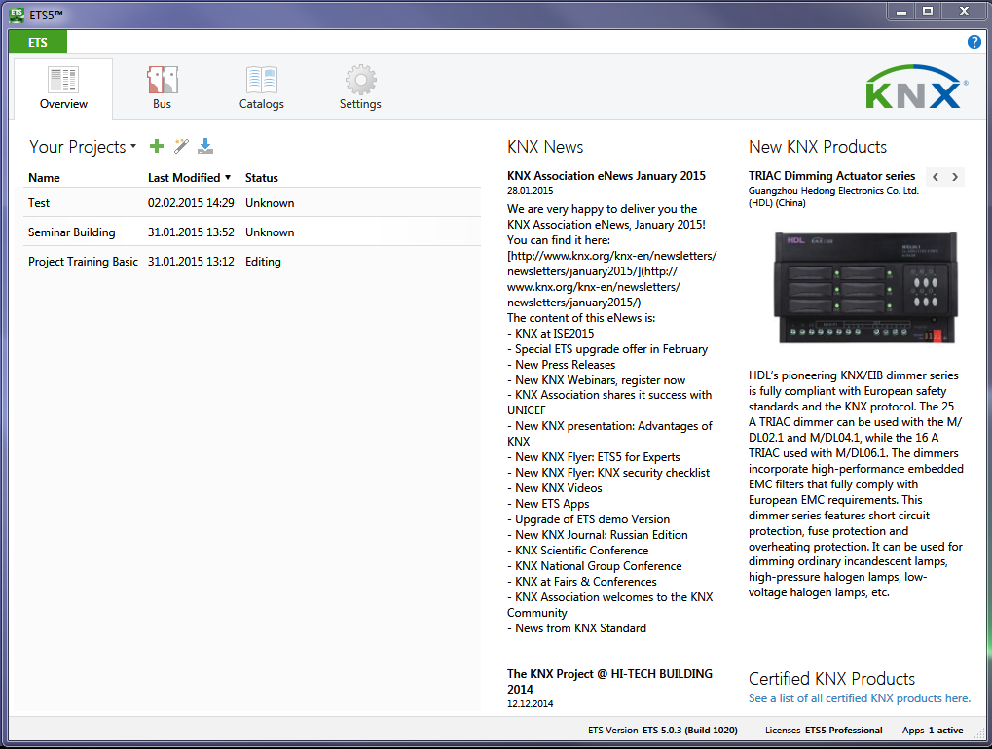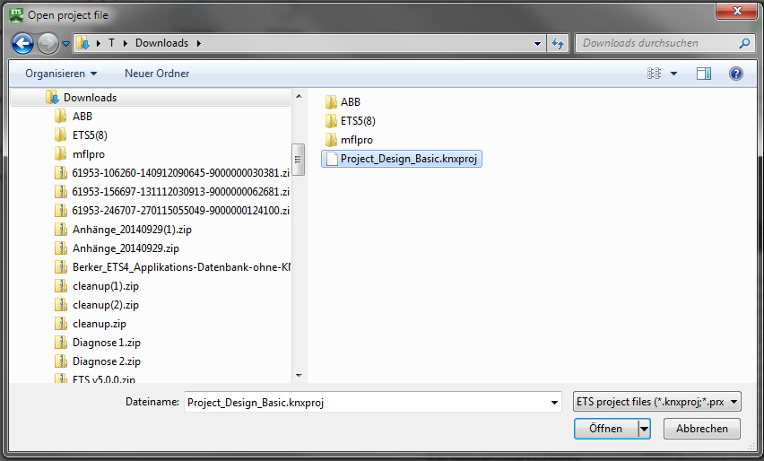

Figure 1: Local or imported projects

Starting the commissioning
You access the embedded commissioning dialog via the Buildings View, Topology View, Group Addresses View or Device View. In the corresponding window, the following menu icons appear for the commissioning or diagnostics purposes (alternative access: menu bar):

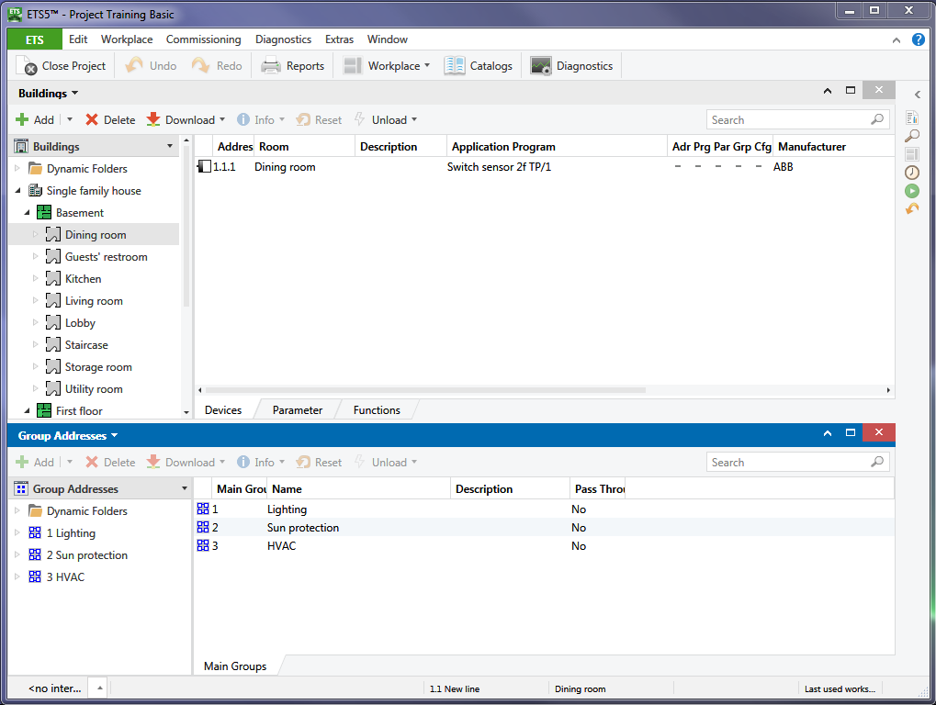

Menu bar
Menu icons
Figure 2: Starting the commissioning

„Add“ | Depending on the opened window you can add: devices, building parts or main, middle and subgroups
„Delete“ | Deletes the latest selection of the current window
„Download“ | Opens a context menu in which you can select if e.g. the individual addresses, the individual addresses and the application program or only the application program shall be downloaded for instance
„Device info“ | Reads out the information contents of a device
„Reset“ | Sends a „Restart“ command to the bus device
„Unload“ | Resets an already programmed devices into the factory settings

Bus access
Before it is possible to start the commissioning process, it is necessary to firstly link the interface for bus communication with an appropriate cable connection to the commissioning PC and then to correctly select the settings on the commissioning PC. This can either be a USB interface, a KNX RF interface or an IP network connection. The communication settings in ETS should be checked at any rate prior to the initial commissioning, regardless of the interface used.
Under the dashboard tab “Bus” you will find the submenu “Interfaces”. Corresponding setting options can be found here.

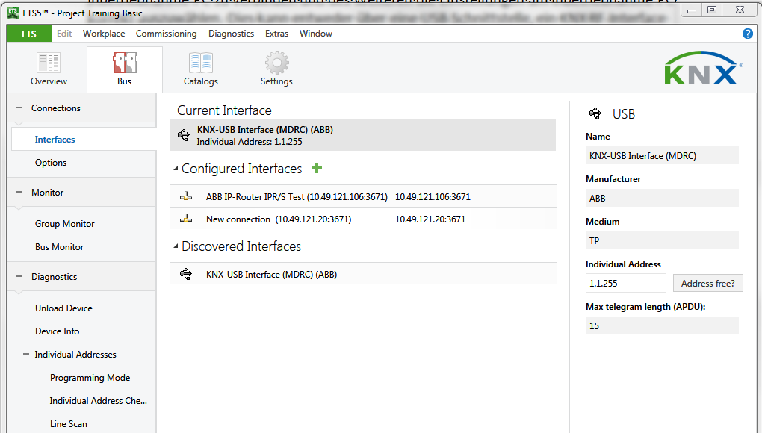
Figure 3: Bus access

Configuring the interface
If you click in the window „Bus / Interfaces“ on the button „+“ the dialog window „new connection“ will be opened. By means of properties you can choose between the following connection options:
- IP (EIBlib/IP), Communication via iETS (APP)
- KNXnet/IP, IP Communication (Tunnelling)

When using a USB interface, a RF-interface or an IP-interface the required KNX USB driver is installed directly the first time a connection is made to the PC and the interface will be shown under „Discovered interfaces“.

Note: This occurs for each USB port i.e. if the USB cable is inserted in another USB port of the PC, the driver is installed again. Possibly, the connection pop-up menu must be opened once more, to ensure that communication functions again.
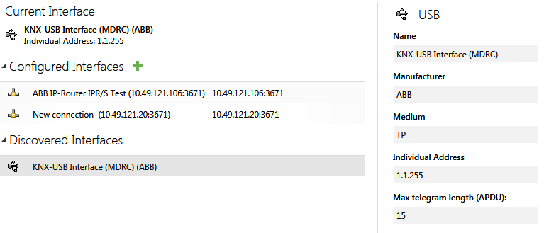
Figure 4: Configuring the interface

The communication type IP (EIBlib/IP) is the predecessor of KNXnet/IP and requires a device with a built-in iETS client. This is software, which is integrated in some IP-Gateways. In case of this type of communication, it is essential to know the IP-Address of the IP-Gateway. This type of communication now is only available by an „APP“.
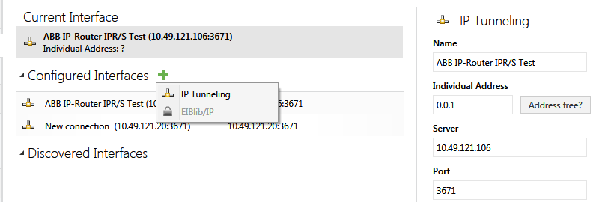
Figure 5: IP (EIBlib/IP)

Via KNXnet/IP, IP-couplers (IP-router) or KNXnet/IP interfaces can be addressed. In this case the so-called “tunneling” method is used. KNX telegrams are wrapped into TCP/IP and sent by ETS to the required IP coupler, which again removes the TCP/IP envelope and routes the KNX telegram to a subordinate lower TP area or TP line.

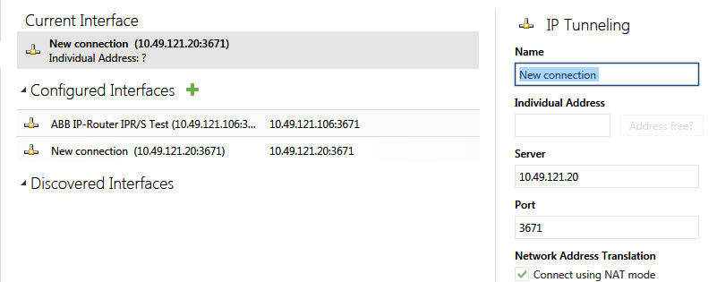
Figure 6: KNXnet/IP

With the communication type “KNXnet/IP Routing”, pure KNX IP devices can be addressed. These are devices that only have an IP connection. The communication type can also be used to carry out a diagnosis of the IP network connection (e.g. group monitor).
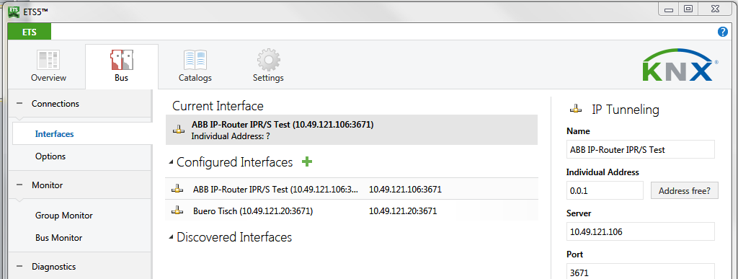
Routing
Figure 7: KNXnet/IP Routing

Configuring the local device
If the current interface is marked in the „interfaces“ view, the settings appear in the sidebar. The individual address of the interface is entered here. The address must be set in such a way, that the area and line number match the current installation location of the interface. The device number must be an address not in use in the project. “255” is the most suitable device number as this high number is probably not present in the installation.
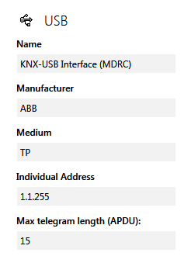

Figure 8: Settings of the local interface

If a flush-mounted interface is used for programming, which is removed from the installation after commissioning and replaced e.g. by a switch sensor, one shall immediately set the individual address of the device that will be present later on in the “normal” operation of the system.

If the local device is a Powerline BCU, a domain address shall also be loaded. A corresponding value can be defined in the “Domain Address” field (see also chapter ‘Powerline’).

Note: Also when using an IP coupler as an IP interface, which will function as a line or backbone coupler during later operation, the local interface must be set. In this case, the IP coupler must adopt an individual address during commissioning, which matches its installation location in terms of the area and line (e.g. 1.1.255) and an individual address during normal operation which suits its function as a coupler (e.g. 1.1.0).

Opening a project
Once the commissioning requirements have been carried out, you access the projects via the “Overview” button on the dashboard. Select the project to be commissioned and open it by double-clicking it.

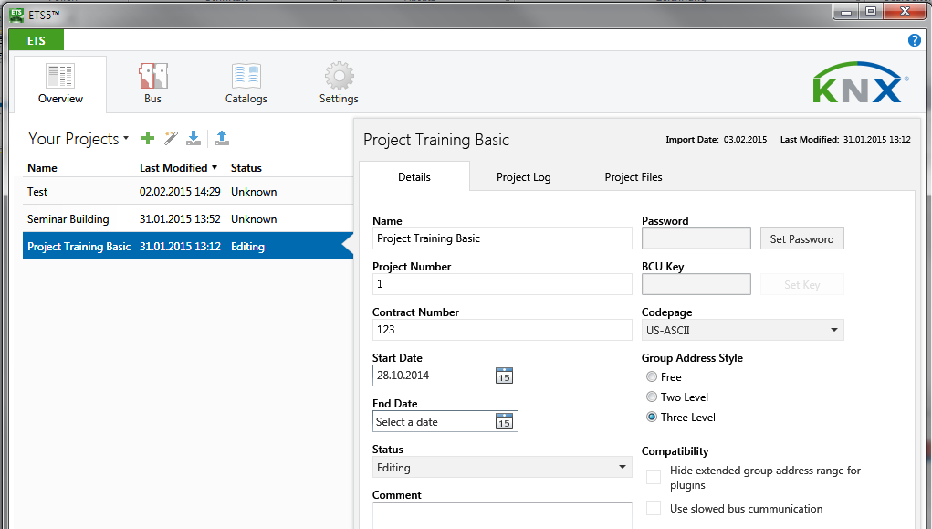

Figure 9: Opening a project

If one sets the interface options, it is of course not needed to close any opened projects. It is however advisable to only keep one project open during commissioning, as it can otherwise quickly lead to confusion.

Selecting a view
All views types can in principle be used during the commissioning phase. Each has its particular benefits. The Building View has the benefit that even if the individual addresses of the devices are not consecutive, it is not necessary to walk great distances on the building site. The Topology View has the advantage that several rooms can be commissioned in one go. In the Topology View, it is also possible to select a line and program it entirely in one go. There is also the possibility to use the Group Addresses View for commissioning. This view has the advantage that one can proceed according to the functions and not according to the topology or physical location of the device.

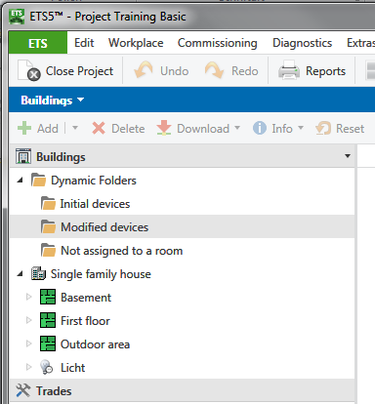
Figure 10: Modified devices

With the exception of the Group Addresses View, one has access in every view to the “Modified devices” via the “Dynamic Folders”. Here only those KNX devices are shown, the properties of which have been modified by the user since their last programming (download).

Downloading
You can access the embedded commissioning dialog via the “Download” button, whereby the following functions are available (alternative access: menu bar Commissioning Download):
- „Download all“ | Download of the individual address and the application program (press the programming button)
- „Download partial“ | Download of the not yet downloaded parts (programmed flag not set)
- „Download individual address“ | Download of the individual address (press the programming button)
- „Overwrite individual address“ | Overwrite the individual address of a selected device (do not press the programming button)
- „Download application“ | Download of the application program

In order to download the individual addresses into the devices, it is necessary to click on “Download Individual address”. After starting the download process, the “Pending Operations” view opens in the side bar. You are now requested by ETS to press the corresponding programming buttons of the devices. The progress of the download process is then displayed in this view.

Note: If a coupler is present, it should always be at the top of the list and thus also be programmed as the first device with the individual address.

Then click on “Download Application” and the program, group addresses and the parameters (and if applicable also the filter table) are loaded into the devices.

Alternatively, the downloading of the individual address and application program can be processed in one step via the option “Download All”.

A partial download can be selected via the “Download Partial” menu. This download option can be applied if only modified data such as group addresses or parameters should be downloaded.

It is possible to continue working in ETS during the entire download process. Only those devices currently being downloaded are blocked for editing.
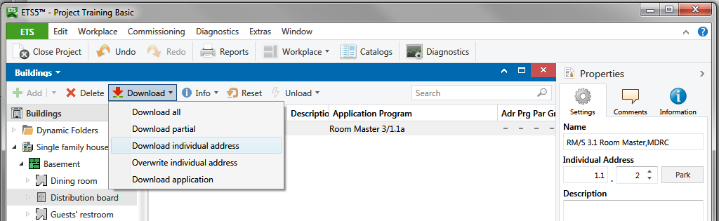
Figure 11: Download

Note: If a flush-mounted interface is used for commissioning which is mounted onto a bus coupling unit that will later serve e.g. as a switch sensor, it must first be downloaded locally. The ETS program automatically detects that it is this type of device and queries in a dialog whether the programming of the local device should be carried out.

Assigning individual addresses
During the commissioning of a KNX installation, it is important that after the interface any couplers available in the KNX project are assigned a correct individual address, before any other device is programmed. The right strategy is to address the coupler in a star pattern; i.e. to download first the coupler(s) of the local line and then all subsequent couplers. Otherwise, communication errors may occur.

Alternatively, it is possible to first disconnect all couplers and individually program the lines. The couplers are then re-connected and programmed one after the other. After selecting the “Download individual address” option, ETS checks whether the device already exists on the bus and then asks you to press the programming button.

As the application program also contains the filter table in the case of a line coupler, it is essential in case of couplers to load also the application program.

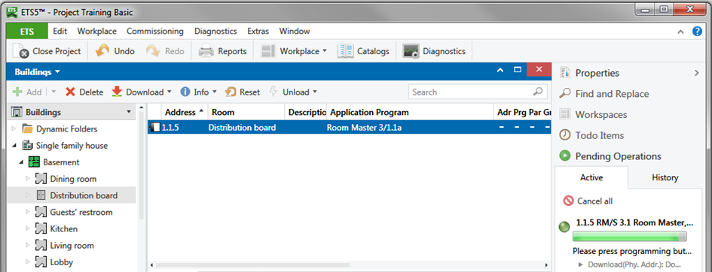

Figure 12: Assigning individual addresses

Loading the application (application software)
A KNX device is only fully functional once the application has been loaded into the KNX device in addition to the unique address (individual address). If the individual address has been loaded, this is shown by the “Adr” entry in the column “Adr Prg Par Grp Cfg.

To load the application, the corresponding KNX devices must be marked in the Buildings, Topology, Group Addresses or Devices View. Thereafter the download of the program can be started by clicking on the menu icon “Download” or via the right mouse button and clicking on “Download”. The current progress of the download can be tracked using the text and status bar.

If after loading, one establishes that changes to the application are still necessary, in many cases it may be sufficient to load the modified applications only partially (“Download Partial” button).

Once the application has been loaded, ETS indicates the download status with the corresponding entries in the column “Adr Prg Par Grp Cfg”:

- „Adr“ | Individual address is downloaded
- „Prg“ | Application program has been loaded
- „Par“ | Parameter setting have been loaded
- „Grp“ | Group addresses have been loaded
- „Cfg“ | Media type specific settings have been loaded (set when downloading the individual address)
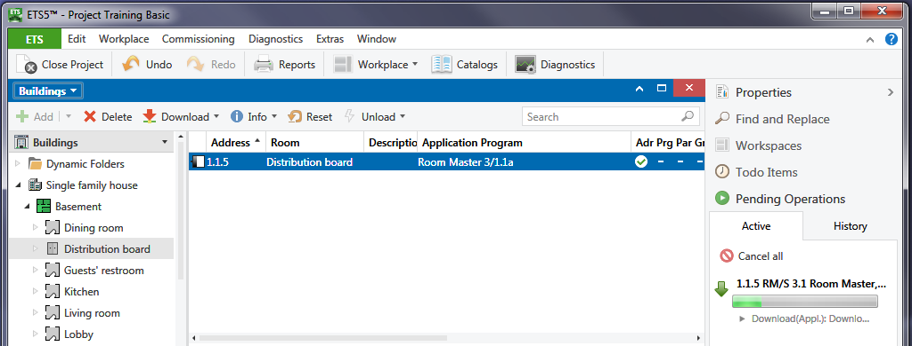

Figure 13: Loading the application

Reconfiguration
If you need to modify a KNX installation, processes are similar to those during project design. When working on a PC, it may however turn out that certain products that are necessary for carrying out the modifications are not contained in the database. This is particularly the case when two different PCs are used for the project design and commissioning e.g. when a desktop PC is used in the office during the project design and a laptop is used on the building site during commissioning. In this case, the missing devices must be imported at a later date.

Implementing project design changes
With ETS, it is possible to implement project design changes during the commissioning phase. Please proceed precisely as already described in the “Project design” chapter. Changes to all relevant settings can be carried out:
- Application program
- Parameters
- Group addresses
- Flags

Reprogramming filter tables
If changes still need to be carried out to individual devices during commissioning affecting several lines, it is necessary to reprogram the filter table. This is ensured by partially reloading the group addresses in the affected line couplers. Of course, alternatively, the complete application can be loaded into the couplers. Only if additional group addresses have been linked to a line, ETS does display the entry “Manual filter table entries”. If manual changes have been carried out here, the corresponding couplers must likewise be reprogrammed (partial: group addresses). Changes are made by “drag&drop” a group address on a physical line and such entering it automatically. A further possibility is to enter it manually. To do so you have to use the side bar. In the first step the line is selected, thereafter you have the possibility to enter the addresses e.g. one after the other.
Note: ETS automatically updates the project filter tables in the background.

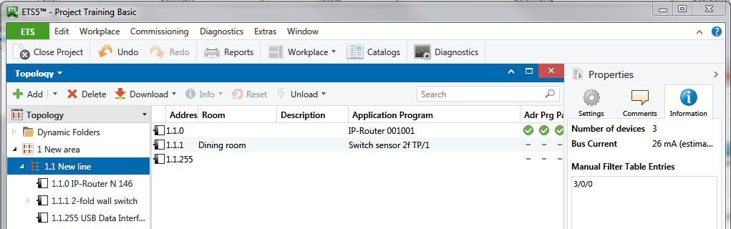
Figure 14: Manual filter table entries

Commissioning devices
Once the project design changes have been carried out, the affected devices must be re-commissioned. To do so, please proceed as described in the first part of this chapter. Please bear in mind that it is also possible to download the devices partially. This can save a great deal of time e.g. if only time related parameters need to be modified for 20 dimming actuators, it is a good idea to download just the parameters rather than the entire application.

Unloading devices
If a device has been loaded by mistake, it is possible to unload it completely in the commissioning menu via the “Unload” submenu, whereby there are two possibilities for this function. The first option is to select “Unload application”: this will leave the individual address untouched in the device. This process will not delete the entire program but simply set all possible error flags. The other option includes the additional unloading of the individual address. To do so, select “Unload address and application” from the menu. For security purposes, ETS will prompt you before each unload process, whether the device should really be unloaded. In addition, the programming button must also be pressed.
If a device has been fully unloaded, the individual address is reset to the original state. An unloaded device has the individual address 15.15.255.
The progress of the unloading process can be monitored in the side bar under “Pending Operations”.

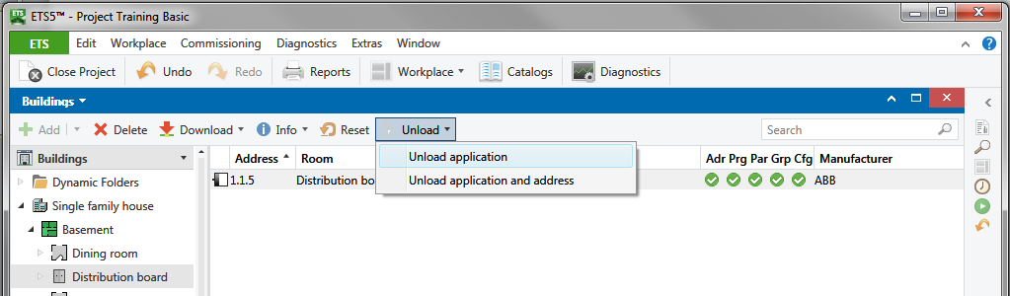
1.

Figure 15: Unloading devices
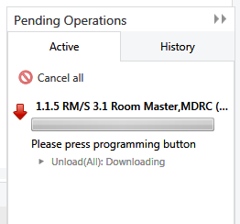
2.…
Figure 16: Sidebar: Unloading devices

Note: It is not possible to unload couplers (the individual address is set to 15.15.0).

Resetting devices
The command “Reset device” can be called as context-sensitive (right mouse click on the corresponding device), via the embedded commissioning dialog or via the commissioning menu. This process is also shown in the side bar under “Pending Operations”.

The reset of a device will restart the bus coupling unit (operating system and application program).
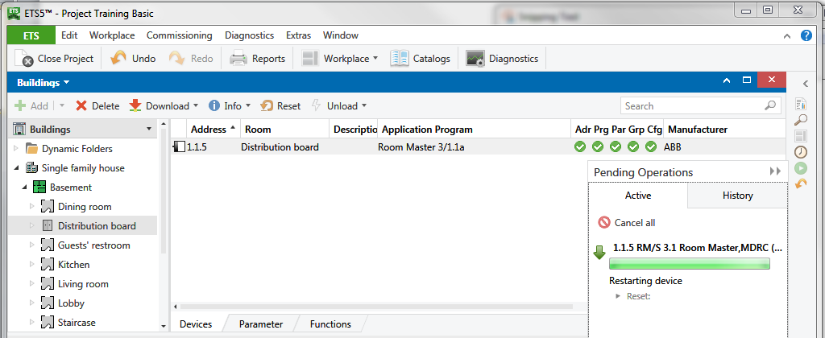
Figure 17: Resetting devices

KNX RF Commissioning

Adding a RF Line
As explained in the RF chapter of the Basic course, it may sometimes be required to extend an existing KNX TP installation, however for local building regulations or aesthetical reasons only using wireless communication. How one can extend the TP Installation with KNX RF products is explained in the following paragraphs:

- Select the Topology View and add a New RF Line to the area. Make sure that the medium is set to “RF”
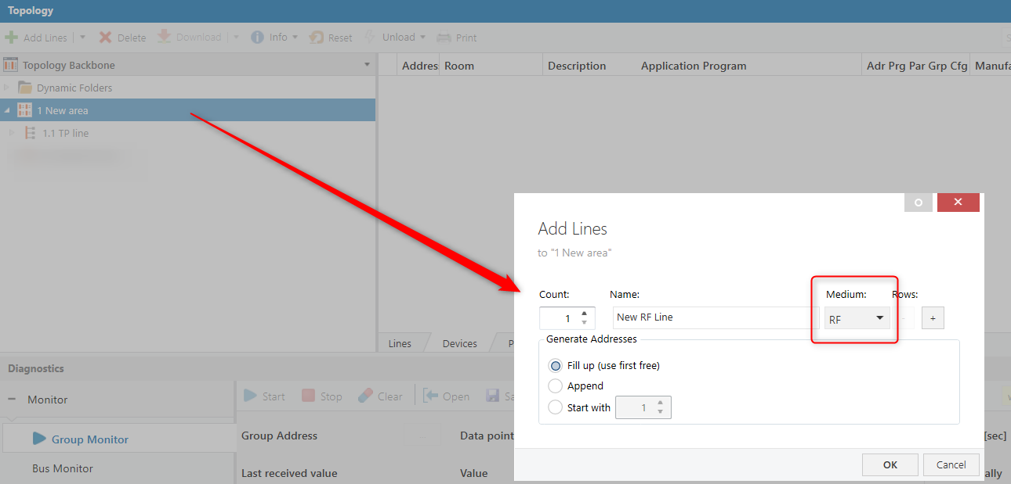
Figure 18: Adding RF line

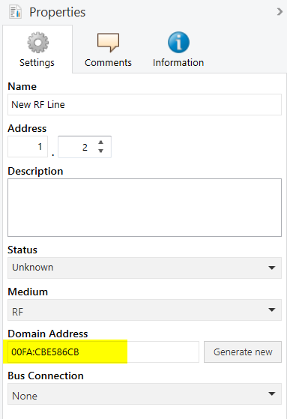
ETS will automatically create a unique 6-byte Domain Address for this newly created RF line. The purpose of the Domain Address is to avoid interferences between other adjacent KNX RF lines. Changing the Domain Address is possible but means that already configured RF devices have to be re-configured.

Figure 19: Domain Address

- Add a TP/RF media coupler to your newly created RF Line with the individual address x.x.0. The media coupler, just like any TP/TP line coupler will route telegrams according to the filter tables calculated and loaded by ETS. Only the group addresses that are contained in the filter table of the TP/RF media coupler will be routed to the other line (and vice versa). The filter table can be previewed via the context-sensitive menu.
Note: Please make sure that your TP line does not have any IP router used as a line coupler (e.g. 1.1.0) as in this case your main line would be IP. Adding a RF/TP media coupler to the RF line requires that you have TP main line instead of an IP line. An IP/RF coupler is commercially not available yet.

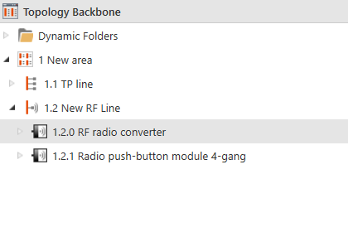 | 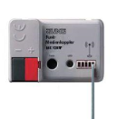
 | 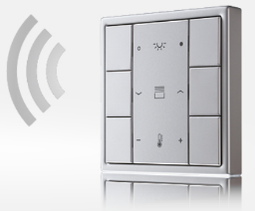

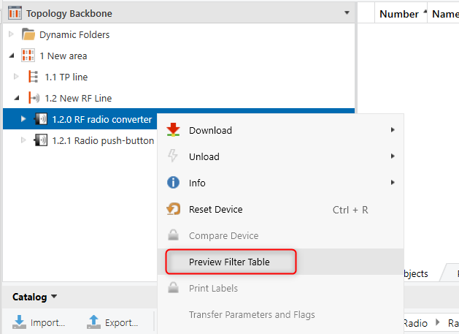
Figure 20: Preview filter table via context-sensitive menu

- A maximum of 255 bus devices can be added to the RF line. The configuration of such KNX RF devices connected to an RF line is absolutely identical to what is explained in the previous chapters for TP (apart from the setting of the object priority, which does not have any effect on RF).

Commissioning a KNX RF Line

The KNX RF devices can be commissioned in two ways:

- Via the TP-RF media coupler: ETS can be connected to the KNX-TP installation via a standard KNX-TP-USB interface (or, alternatively, you can commission the devices via a KNX-IP Interface or Router connected to the TP installation).
- Using a direct KNX RF data interface (USB-RF dongle), which allows ETS to connect with the RF domain and configure the existing KNX-RF devices directly from the PC.
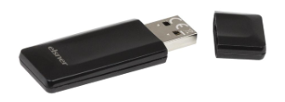
Figure 21: KNX RF data interface

