English assignment: Communication and marketing
Your colleagues have already noticed that YOU (the new trainee) have great artistic skills and therefore they want you to make an advertisement (a print ad) for an English newspaper as part of a new marketing campaign “Give me Sports this Christmas”
SPORTMASTER wants to promote its new campaign, in connection with the Christmas season.
Make the advertisement showing at least two offers, which you think will be popular for this purpose.
Think about the AIDA model and the Communication Model when designing it.
Use a suitable computer program like Publisher to make the ad.
At the exam:
- Present your advertisement at the exam.
- Explain your choice of colours, target group, prices, and reasons for choosing the products.
- Link: https://sportmaster.dk/jul

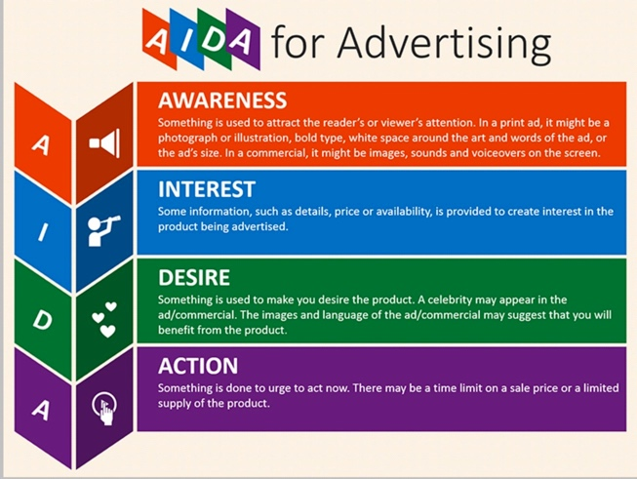

Advertisement analysis: The Communication Model
As well as using the AIDA model it is important to know your receiver of the advertisement. Only when you know your receiver, you will be able to choose the proper media and message for your advert.
The Communication Model
- Sender
  - Who is the sender?
  - What is the message? And what are the intentions behind the advert?
- Media – Content/language/layout
  - What is the story about?
  - What does the advertiser want to achieve?
  - What is the language like? Short/long sentences, slang, technical terms, etc. Describe the relation between pictures and text.
  - How can you see the identity of the sender?
  - Describe the pictures:
    - What are they of?
    - Are the pictures manipulated or genuine?
  - Which colours are used and how do they add to the atmosphere?
- Receiver
  - Who is the target group? (demographics i.e. gender, age, income, job and education)
  - Who is buying the product? (lifestyle segments)
- Conclusion
  - The AIDA model:
    - Does the communication in the advert work?
    - Does the advert make the receiver go through all stages in the model? Explain how?

Trykt reklame

